**Mapit Spatial  
GeoPackage Manager**

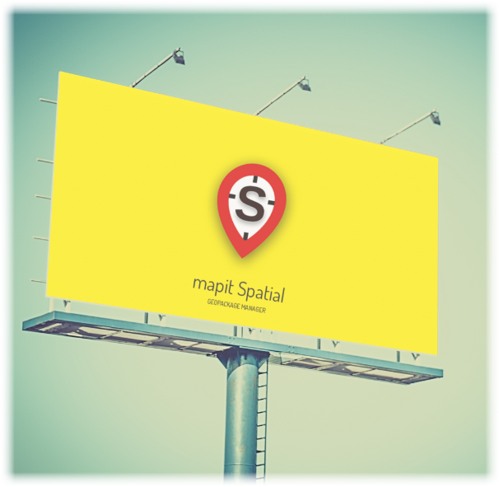

Mariusz Prociuk

Translated into English by Andrzej Bieniek

Mapit Spatial – User Guide

Content

|  |  |  |  |  |  |
| --- | --- | --- | --- | --- | --- |
|  |  |  |  | Introduction……………………………………………………………..... | 4 |
|  |  |  |  | Map screen……………………………………………………………........ | 7 |
|  | ………………………… | | | Navigation between the app modules…………………………… | 9 |
|  |  | …………… | | Online maps …………………………………………………………….... | 10 |
|  |  | …………… | | Services Management WMS, WFS and other ………………… | 11 |
|  |  | …………… | | Offline Maps……………………………………………………………..... | 14 |
|  |  | …………… | | Data management - Geopackages………………………………… | 17 |
|  |  |  | … | Geopackages Tab………………………………………………………… | 18 |
|  |  |  |  | GeoPackage Export ……………………………………………………. | 19 |
|  |  |  |  | Removing GeoPackage ………………………………………………. | 20 |
|  |  |  |  | Creating new GeoPackage…………………………………………… | 20 |
|  |  |  | … | Layers Tab……………………………………………………………....... | 22 |
|  |  |  |  | Create New Layer………………………………………………………. | 23 |
|  |  |  |  | Data Import – General Information ……………………………… | 24 |
|  |  |  |  | Import layer (geometry and attributes) ……………………… | 25 |
|  |  |  |  | Import data into existing layer (geometry only) …………. | 28 |
|  |  |  |  | Layers Management…………………………………………………… | 30 |
|  |  | …………… | | Attributes Management …………………………………………….. | 51 |
|  |  |  | … | Create attribute set …………………………………………………… | 52 |
|  |  |  |  | Edit attribute set……………………………………………………….. | 53 |
|  |  |  | … | Export and Remove attribute set ………………………………… | 57 |
|  |  |  | … | Import attributes ………………………………………………………. | 59 |
|  | …………………………. | | | Search for places addresses and coordinates………………… | 60 |
|  | ……….............. | | | GPS/GNSS Status ……………………………………………………… | 60 |
|  | …………............... | | | Status Bar …………............................................................................................ | 61 |
|  | …………............. | | | Spatial reference ………….............………….............………….............…………...... | 61 |
|  | …………............. | | | “Centre on GPS” switch………….............………….............………….................. | 62 |
|  | …………............. | | | Map Centre cursor………….............………….............………….............……………. | 62 |
|  | …………............. | | | Map scale………….............………….............………….............………….............……… | 62 |
|  | …………............. | | | Adding points or vertices………….............………….............…………............. | 63 |
|  | …………............. | | | Quick measurements………….............………….............………….............………. | 71 |
|  | …………............. | | | Zoom controls………….............………….............………….............…………............. | 72 |
|  | …………............. | | | Coordinates………….............………….............………….............………….............….. | 72 |
|  | …………............. | | | Save map screenshot and Application Settings…………............... | 73 |
|  |  | …………… | | General Settings………….............………….............………….............…………......... | 75 |
|  |  | …………… | | Units and coordinates………….............………….............………….................... | 81 |
|  |  | …………… | | Survey Settings………….............………….............………….............………….......... | 84 |
|  |  | …………… | | Miscellaneous Settings………….............………….............………….................. | 91 |
|  |  | …………… | | Remote Connections………….............………….............…………....................... | 94 |
|  |  | …………… | | External GNSS………….............………….............………….............…………............. | 95 |
|  |  | …………… | | Cloud accounts………….............………….............………….............…………........... | 98 |
|  |  | …………… | | About and Feedback………….............………….............………….............………… | 98 |
|  |  |  | | APPENDIX 1 – Mapit Spatial Folder Structure…………................. | 99 |
|  |  |  | | APPENDIX 2 – Mapit Spatial vs Mapit Pro………….............………….. | 100 |

**Introduction**

It has been now 4 years since first version of Mapit GIS Data Collector has been published on Google Play and I am not afraid to say that the project has been highly successful and the app is being used by thousands of users every single day all over the wold. Over the years the app was evolving – we have tried hard to listen to the user feedback and make the application as flexible and useful as possible – we have always however tried to keep the balance between the complexity and the light design, so the app can be used even by users which are not necessarily GIS or Survey experts.

The above approach worked very well – however the technology these days is changing fast. Particularly in the “spatial” world the number of the data gathered during the land or environmental surveys can be very large. Listening to our users and seeing the need for improvements we have started to look at possible options and we have decided that building an app around new OGC Standard called GeoPackage makes perfect sense and it will greatly improve data management capabilities of new application.

We have also agreed that the current functionality of Mapit Pro is optimal for most users and we have decided to keep both apps as similar as possible in terms of design and user interface.

So, here we are – starting from January 2019 Mapit Spatial is available and version 1.5.0 is now fully compatible in terms of functionality with Mapit Pro.

We are hoping that everyone who used to work with original version of Mapit will be able to switch to new application without major headache and any new or changed features will not cause a problem with the workflow.

For everyone who feels however a bit lost with the new app design or for users who are only starting the journey with new Mapit Spatial product we have designed this guide and we will try hard to clear out all of the doubts which may have appeared.

Our promise is to keep the app as easy and as user friendly as possible for everyday tasks, even it hides some powerful tools behind the scenes.

In terms of major changes - as we have mentioned on the beginning one of the most important things is completely redesigned data management approach. New OGC GeoPackage format has replaced basic SQLite database. In fact, now every single layer is a separate spatial table as we know it from standard GIS applications. The above comes with all the benefits like improved drawing efficiency, native support for projected coordinates, spatial indices, support for multigeometries and more.

In relation to the fact that each layer is now separate database table there is also new way of working with the attribute sets (these in Mapit software are used to define things like for example dropdown lists on the data entry form). In contrary to Mapit Pro now each layer’s field can be linked separately with the attribute set field and even different fields in the same layer can be linked with fields coming from different attribute sets. The most important thing is to make sure the data type matches for both: layer and attribute set field.

The nature and beauty of the GeoPackage format is its interoperability and versatility. Most of the leading GIS Software packages like qGIS [https://qgis.org] can access GeoPackage data directly. So, if you need your data transferred to the PC for post processing or vice versa – now it is a matter of getting the GeoPackage file transferred to get immediate access to all the layers. Of course, we have maintained the functionality of exporting Mapit data to number of popular formats like geojson, shapefiles, KML and more.

The GIS Software and spatial data gathering and processing is getting more and more popular these days all over the world and the ability having quick, fast and reliable workflow is becoming very important. Mapit Pro has become a day to day tool for thousands of people across the world and we are hoping that Mapit Spatial is going to improve and make your workflow even more efficient and cost-effective solution.

We would like to address our application to everyone who is working with spatial data and is responsible for any kind of location related tasks. There is number of science and business-related areas relying or depending on the accurate information coming from Geographic Information Systems and we do hope Mapit Spatial is going to become your day to day tool when you are making things right out there in the field.

Particularly the app is dedicated to people who are working in agriculture, forestry, housing development or land survey industry, but also to customers responsible for design work in power industry, water supply and sewage systems, gas industry, telecommunication and road engineering. Mapit Spatial can be also adopted for any kind of spatial asset management tasks, fishery and hunting, habitat and soil mapping or to whatever needs you can think off, but of which the authors of the application have never thought.

If you enjoy the app and have got your own story or you are using the app for very specific tasks and you want to share it with us, please do not hesitate to get in touch and we will be happy to share your story on our website.

On the next pages we will try to transfer some knowledge which is required to make the most out of the app and we do extent on some areas which might be looking confusing for the first-time users or people coming from Mapit Pro environment.

Here we go, let’s start hour your journey with Mapit Spatial and make it your friend.

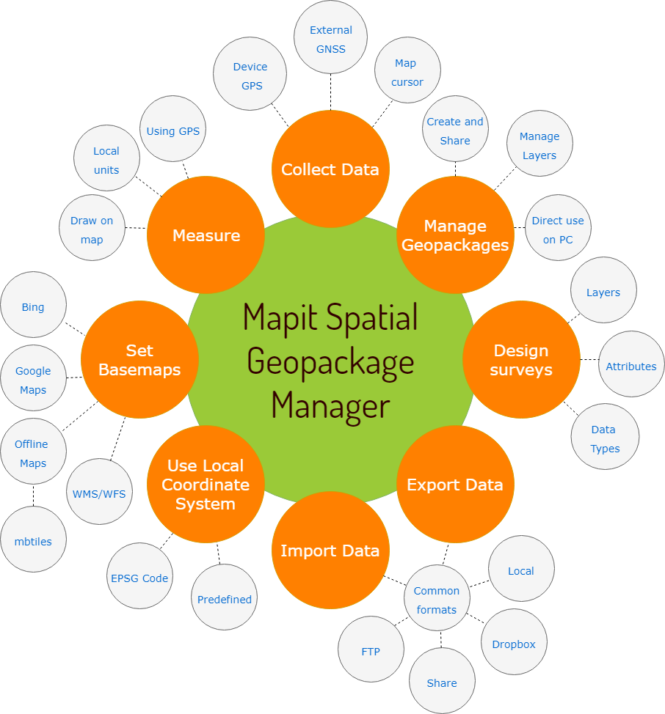

**Map screen**

When the app is started you will be presented with the map screen which is the main window of the application. The map state is remembered when you leave the app and it always will be restored to the state of last session when the app starts. Below you can see description and location of the main elements of the map view, however when looking closer at other app functionality we will get back to this view and will provide some additional information related to this screen if necessary.

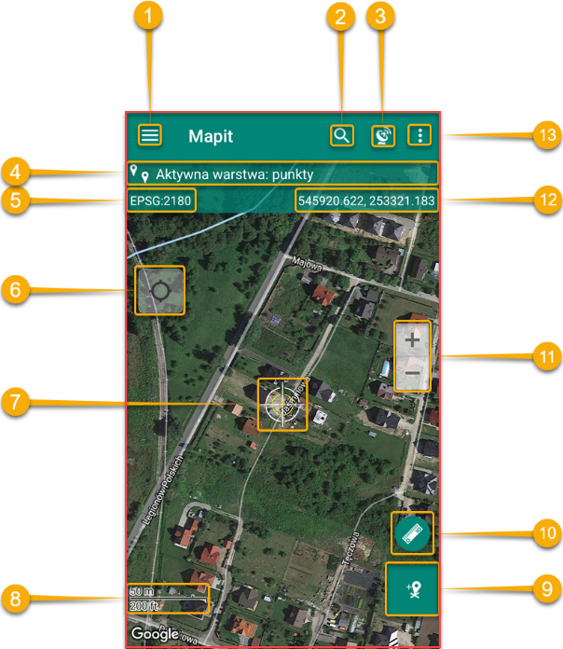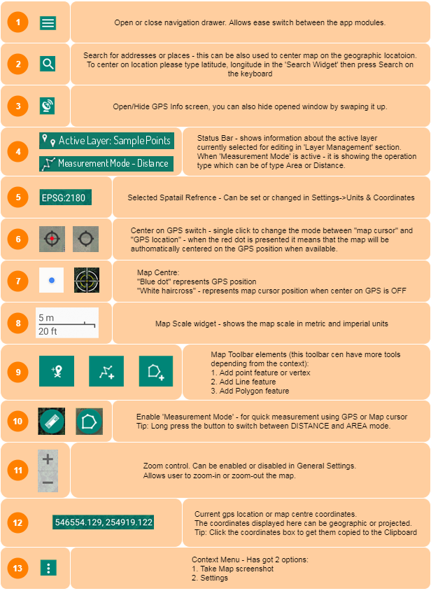

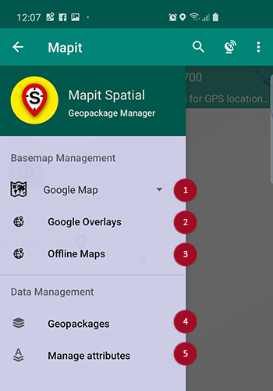  
By taping the icon or swapping from the edge of the screen to the centre, you can access the main menu allowing to switch between the main app modules.

This menu is called a „navigation drawer” and it will be reference as that further down in this document.

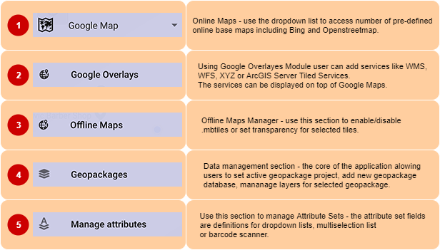

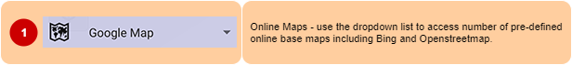

Online maps allow you to select the type of basemap for the actual needs. One of the options allows also to switch off the background map completely. Please tap selected dropdown element (on the left-hand side of the little arrow-down) to select the actual map.

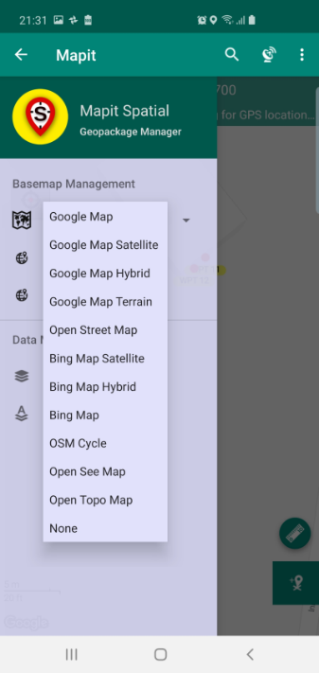

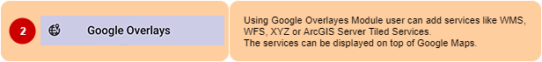

On top of Google Maps Mapit Spatial is able to display additional layers of information available as so called “Google Overlays” which can be a service like WMS, WFS, OSM (XYZ) or ArcGIS Tiled. Use navigation drawer „Google Overlays” menu item to access services management screen.

Services management screen has got few tabs. Each tab does contain some sample services – it is up to user to keep them in or remove if they are not relevant for their area. Users are able to add their own services – please use the + icon to start the process. Some services need more information than others, the most important is the service endpoint (URL).

For example, in case of adding WMS, please provide the Name (can be any text) and the URL. To move to the next step please press “Connect”.

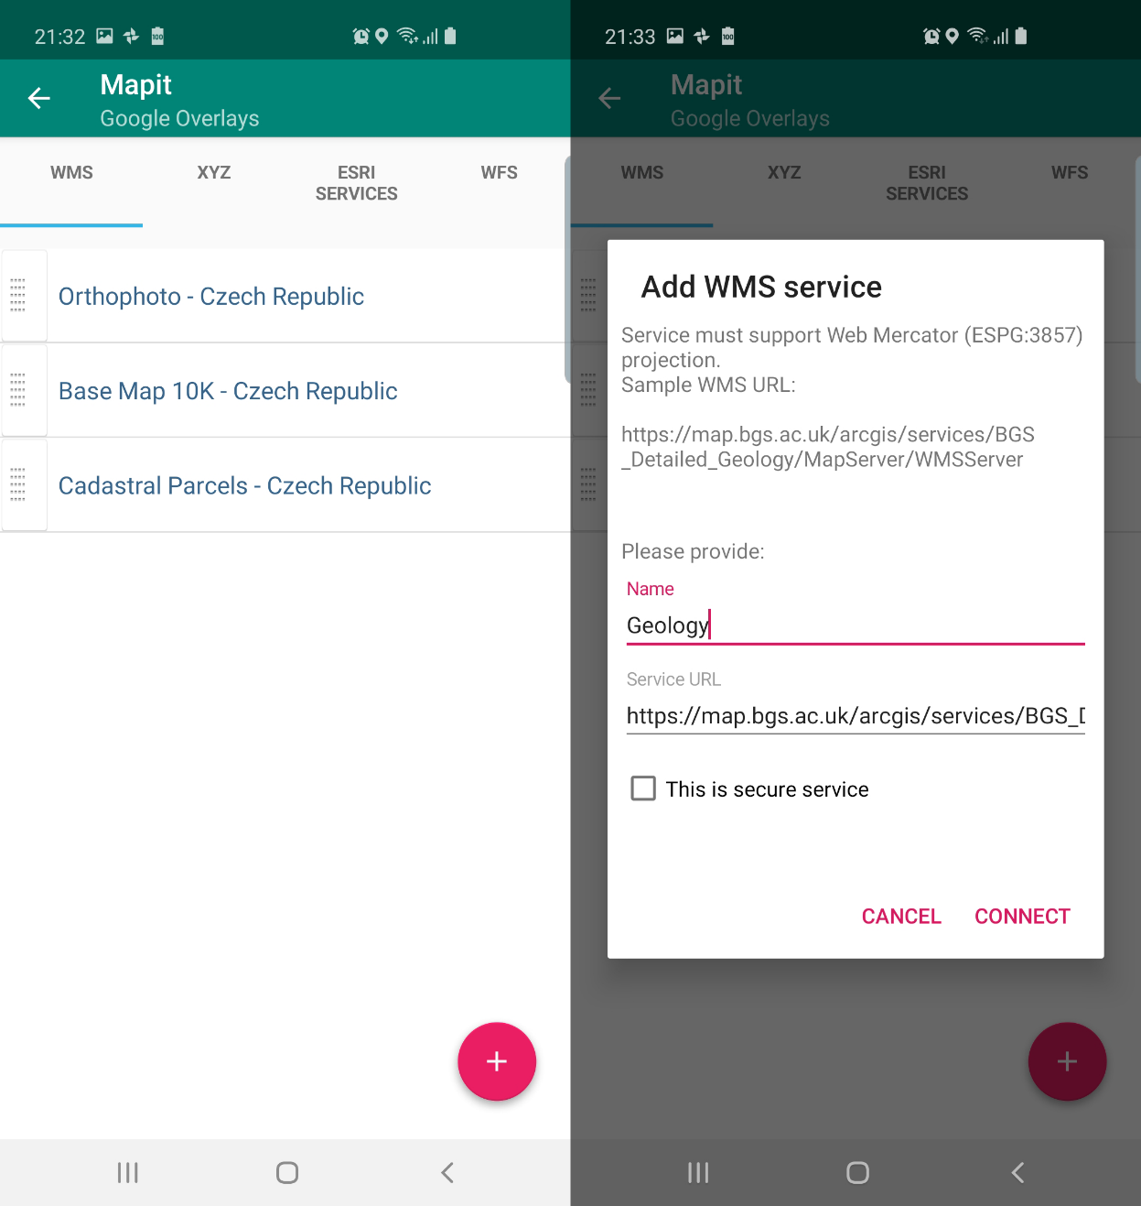

When the connection is successful user will be presented with the available layers. Please check the checkbox to get the layer selected. By pressing the ‘i’ button some general service metadata is being displayed if available.

To save the configuration please press “Save Service Configuration’ button.

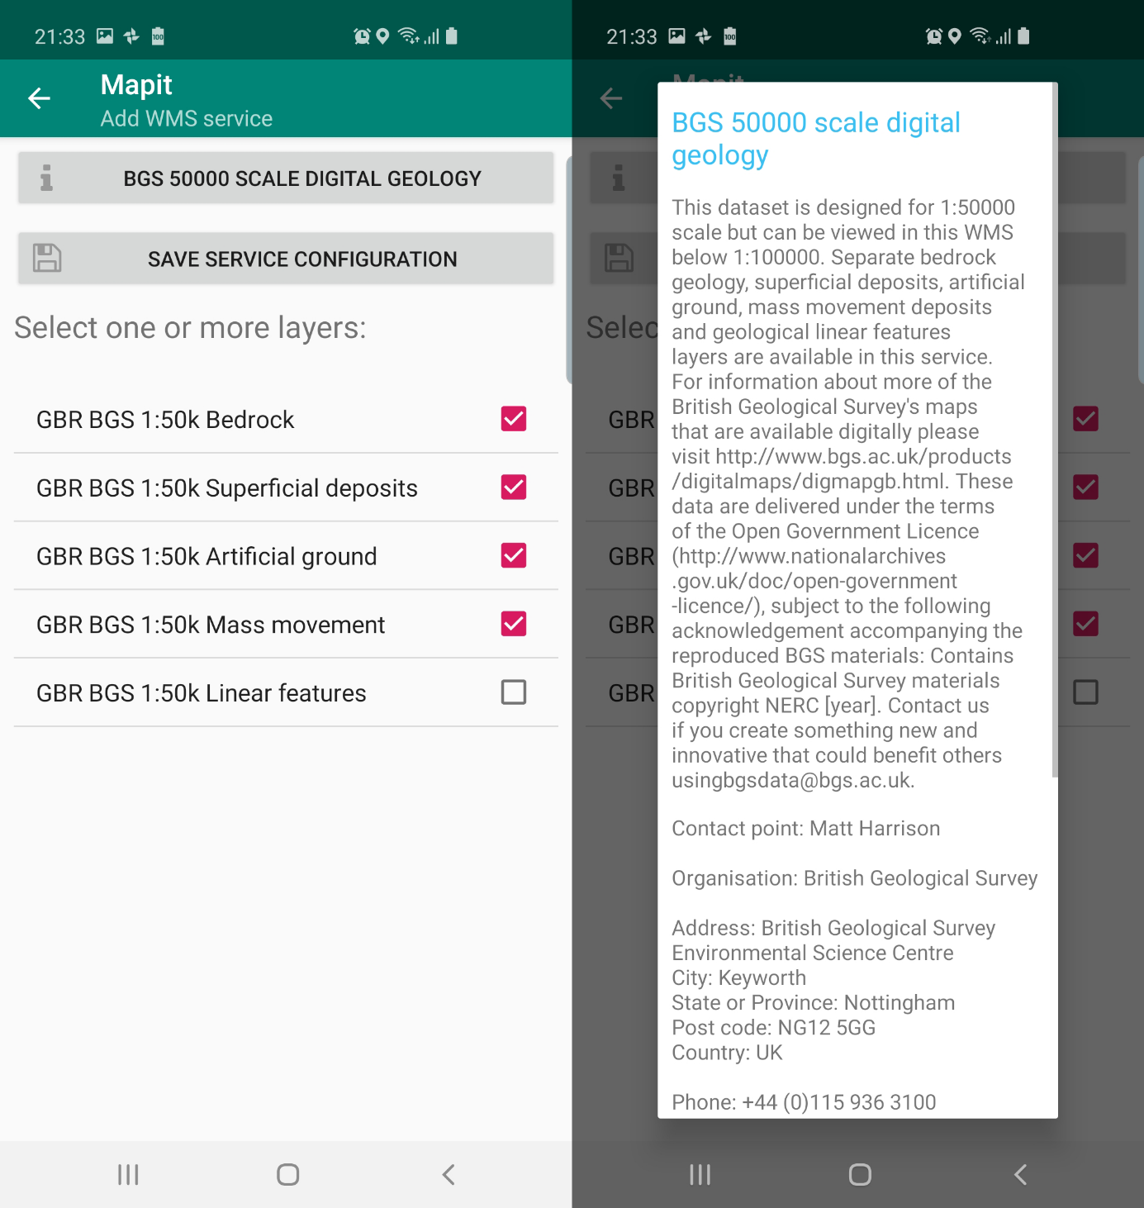

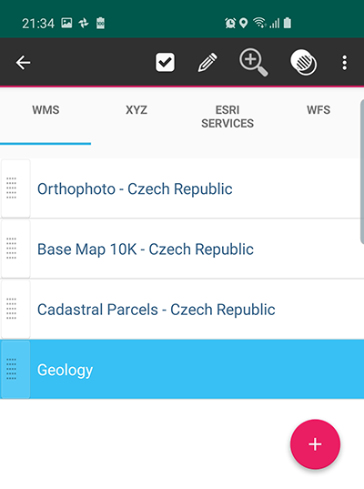When a list element is selected following options are available:

To activate the service and get it displayed on the map, please select the required service on the list than click  icon.

If you are displaying more than one service of certain type on the map – you can drag the selected service down or up – using the “drag” element on the left-hand side of the list. This will force to display the services in the order specified by the position on the list.

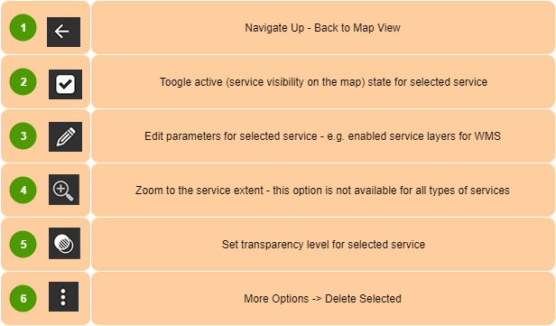

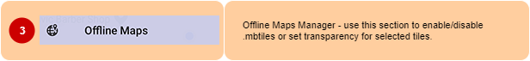

If you are working in remote areas and need to use a background mapping without the Internet connection you can use so called. mbtiles files to do so. To use .mbtiles in Mapit you need to prepare your data using e.g. qGIS or other 3rd party apps like Maperitive or MapTiler. You can prepare that way raster or vector data.

Ready .mbtiles must be transferred to the internal device memory and placed in Mapit-Spatial→Offline Maps folder. Then the content of that folder will be available when “Offline Maps” option is selected from the navigation drawer.

In Mapit Spatial alternatively to .mbtiles you can utilise a tiled layers directly in GeoPackage itself, so if your GeoPackage contains the tiled layers, they can be activated via Geopackages→Layers Management section.

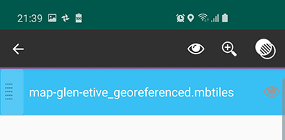Following options are available for selected .mbtiles file in the “Offline Maps screen.

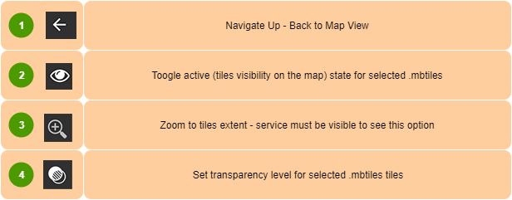

Option 3 is available only when the .mbtiles layer is set as visible.   
Please follow the steps below to get the offline layer displayed on the map.

1. Access Offline maps section by selecting “Offline maps” in navigation drawer.

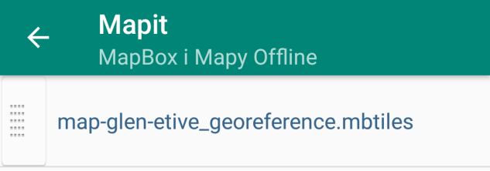

1. Select the required .mbtiles file from the list – selected element will be highlighted in blue.

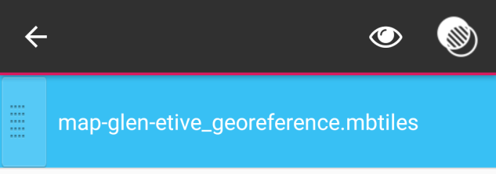

1. Tap the „eye” icon from the context menu to toggle visibility. Visible .mbtiles are marked by the “eye” icon on the right-hand side of the name. Additionally, the “zoom-to” icon will be displayed.

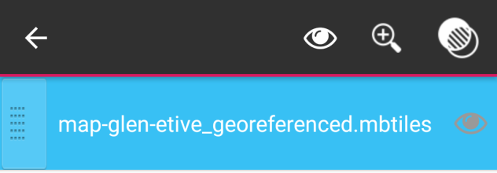

1. 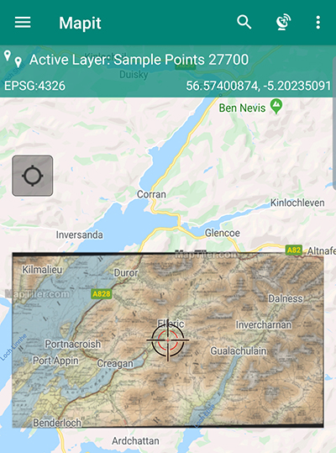Please tap the „zoom-to” icon to switch back to the map and get the map cantered on the .mbtiles extent.

In case you need to make the offline map more transparent, you can adjust the transparency level by selecting the .mbtiles file from the list and pressing “Change transparency” icon. Following dialog window will be displayed allowing to change the transparency level.

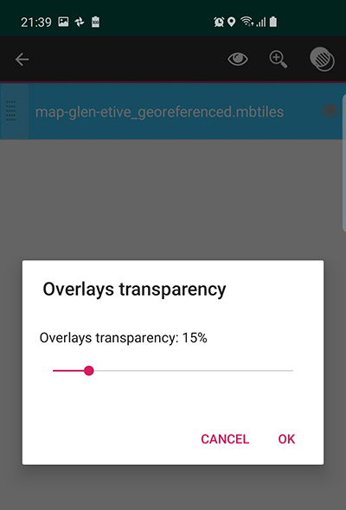

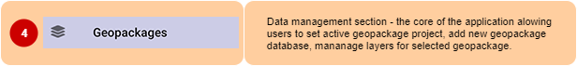

This is the core of the application in terms of the data management tasks.  
After selecting „Geopackages” item from the navigation drawer user will be presented with 2 tabs. First one is dedicated to the management of GeoPackages and the second one (Layers) is displaying content of the GeoPackage marked as active.

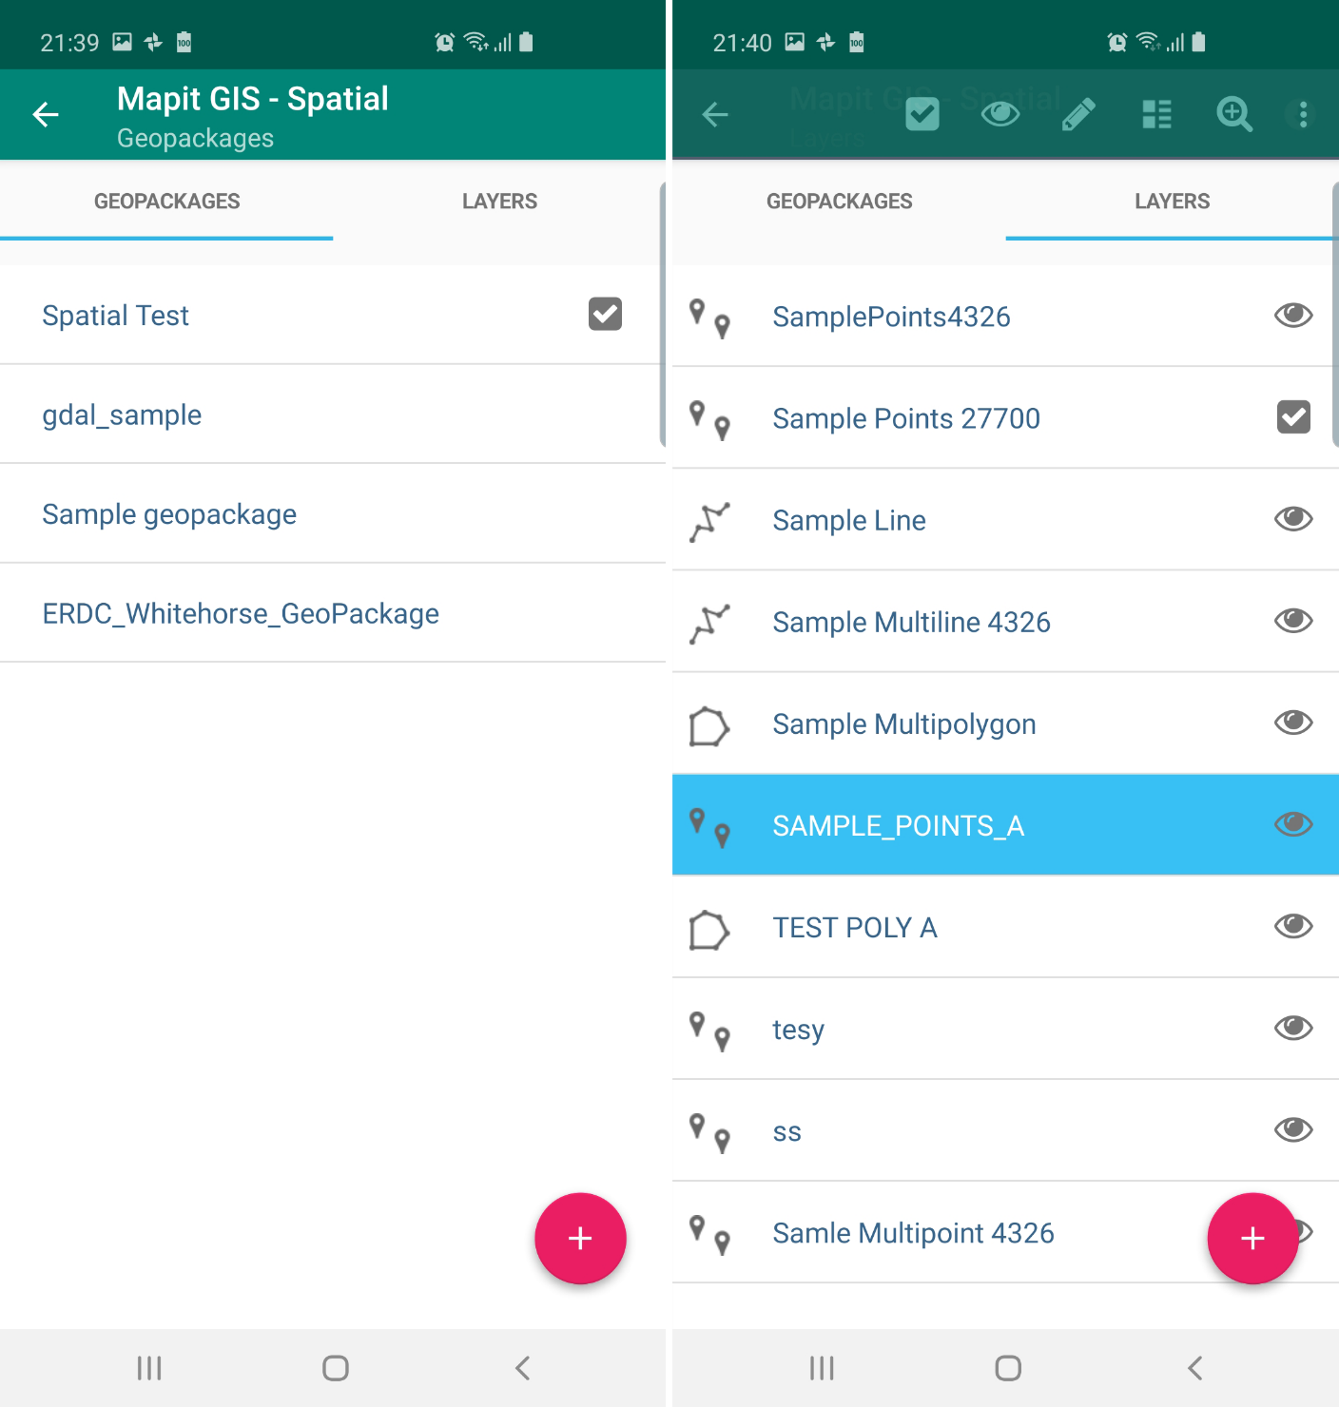

After the installation of Mapit Spatial the “GeoPackage” tab contains sample GeoPackage database called “Sample GeoPackage”, and the “Layers” tab displays three sample layers “Sample point layer”, “Sample line layer” and “Sample polygon layer”. These layers are integral part of the selected GeoPackage file – Sample GeoPackage.

The sample GeoPackage which we may refer also to as the „database” is fully functional and users can use it straight for recording some data, but generally it can be removed and user can start defining its own data structure in terms of layers, attribute sets etc.

**Geopackages tab**

There are 2 ways of getting the GeoPackage tab populated with the entries:

1. By placing the Geopackages files in Mapit-Spatial→Geopackages folder – this can be files prepared in desktop GIS like qGIS.
2. By adding new GeoPackage database directly in Mapit Spatial – in that case new file will be created in Mapit-Spatial→GeoPackage folder.

User can select one of the listed GeoPackage database and make it „active” by selecting relevant option on the context menu. The “active” state can be change back to “non-active” by pressing again the same option.

If the GeoPackage is marked as “active” and user is activating another GeoPackage – the previously “active” GeoPackage will be de-activated.

 

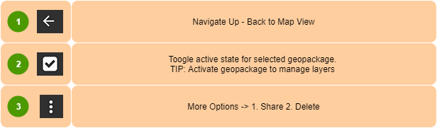

GeoPackage database can be exported as .gpkg file. To do so please select relevant option from the context menu which is visible after selecting the element on the list. Specifically, please press and then select „Share” option.

 

To delete GeoPackage – please select  than press “Delete” – The warning dialog will appear. Please be very careful when using this function. It removes all the files related to GeoPackage and all data including layers, attribute sets saved for this GeoPackage and online services.

Note: Each GeoPackage contains its own set of online services and attribute sets. When GeoPackage file is copied over to another device these will be also available.  
  
You can share .gpkg files using standard Android share chooser (e-mail, Bluetooth, Gmail, Slack, WhatsApp etc.) but other options like FTP/SFTP or drobox are also available.

In lower-right corner of the “Geopackages” tab you can see the + button – please use it to create new GeoPackage database.



After clicking  button, the „Create GeoPackage” dialog will be displayed, where you should type required database name. Press “Yes” to add new database and close the window.

Newly created database will be displayed as new list element on the „Geopackages” tab. To be able to configure your database further by creating new data layers (database tables) – please make the GeoPackage active.

As mentioned above – ONLY ONE GeoPackage can be active at the time and “Layers” tab is displaying ONLY layers which are integral part of selected GeoPackage.



**Layers Tab**

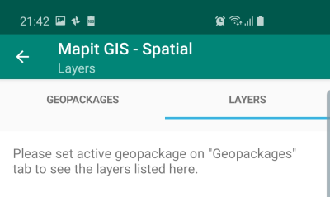To be able to start working with the layers on the „Geopackages” tab you need to activate the GeoPackage database (project) you wish to work on. If there is no active GeoPackage you will get following message displayed:

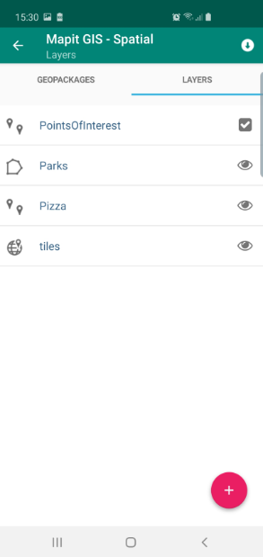When the GeoPackage is marked as active the „Layers” tab will list all vector and tiled layers included in selected GeoPackage database. In fact, each GeoPackage layer is a database table and we may refer to it as that in some areas of this document.

On the left-hand side is an example of the GeoPackage database contains both: vector and raster data in form of tiled layer.

The layers can have 3 states

1. Active – will be displayed on the map, new features can be added only to ‘active layer’
2. Visible – will be displayed on the map and the features belonging to these layers can be edited.
3. Not active and Not Visible – features will not be displayed on the map.

**Adding new layer**

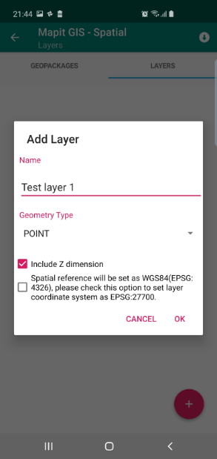Please use ‘Add’ button to add new layer to the GeoPackage database.  
  
When you click the button “Add Layer” dialog will be displayed. Necessary information like layer name and geometry type “POINT”, “LINESTRING” or “POLYGON” must be provided.

You can decide if you want to include Z as part of your geometry. This option is enabled by default.

If user is having local coordinate system set in Settings → Units & Coordinates settings, additional option will be available to use this coordinate system.

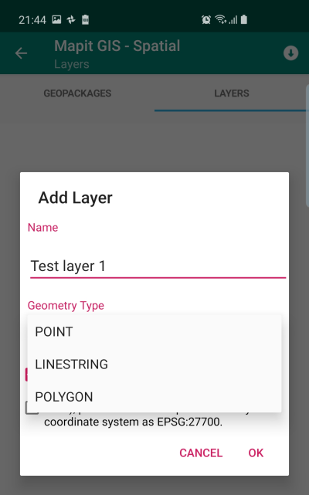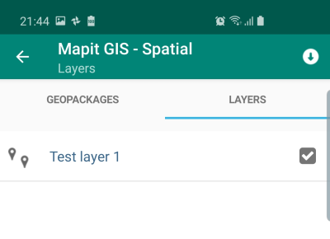By default, the spatial reference for the layer is set to WGS84 (EPSG: 4326).

Please press „OK” button to see the layer added to the list.

Newly created layer automatically will be set as “visible” – and it is symbolised by the ‘eye’ icon on the right-hand side of the layer name.

The newly created layer is ready to be activated and we can start gathering geometry objects for it like registering new points or creating lines or polygons accordingly to the geometry type.

However, if the intension is also to gather some attributes data – and usually that’s the case, the layer must be further customised by adding some fields and optionally link those fields with the attribute set in case we would like to enter the data using predefined lists, like dropdown lists or multi-selection lists.

In general – each filed will be presented as standard Text Box on the entry form unless is linked to the attribute set. There are exceptions from this rule, however we will come back to this further down.

**Data Import – General Information**

It is very important to understand that there are 2 types of import operations available in Mapit Spatial

* Import Layer with existing attributes
* Import geometry only INTO existing layer.

First option is most common, however there are occasions when for example we have got a layer defined – it does contain all the necessary fields and links to the attribute set, but we would like to add for example 200 new polygons to it – to get them resurveyed or so. In that case we can make use of the second option and import geometries only, but all existing attributes simply will be ignored during the export.

Below we have described both options in more details, but we would like to stress one more time that it is very important thing to understand the difference between these two import options.

**Import Layer - Geometry and Attributes**

Apart from the possibility of adding a layer there is also import functions available in Mapit Spatial. Using “Import with attributes” option we will import existing GIS data in form of file like for example geojson or shapefile into the geopackage database.

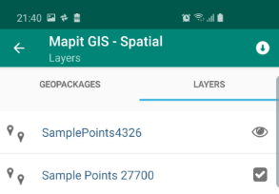If you want to import “with attributes” – please make sure none of the layers on the list is selected in “Layers” tab.

When the selection on the list is cleared – you should see only one icon on the context menu in the “Layers” tab as shown on the picture on the left.

Please press the icon to get to the “Import” module.

At the moment the files can be imported from:

1. **Internal device memory** – please place your files into Mapit-Spatial→Import folder.
2. **FTP/SFTP** – please configure the connection details in Settings→Remote Connections.
3. **Dropbox** – the authorisation must be set in Settings→Cloud Accounts.

At the moment Mapit-Spatial can import the data from following formats:

**Geojson, shapefile, kml, csv, gpx**.

When you copy the import files to the proper location on your device memory (Mapit-Spatial→Import) under the “DEVICE” tab of the import module there will be containers 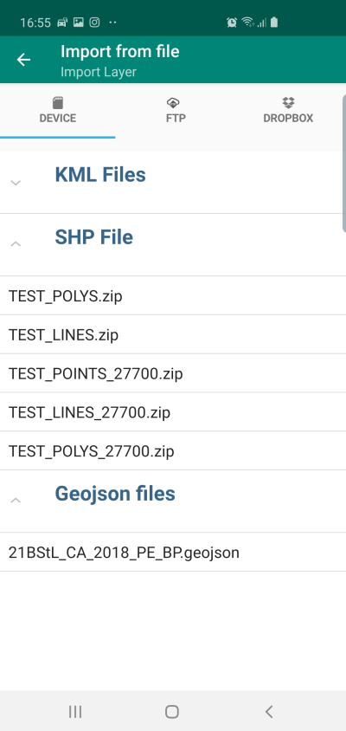displayed for each file type. The number of containers will depend from the formats of the files, so for example if you have only geojson files in the import folder only “Geojson Files” card will be displayed.

Please press the card e.g. “SHP File” to get the category extended and the files available for import listed.

Please select the file from the list and press the  icon to start the import process.

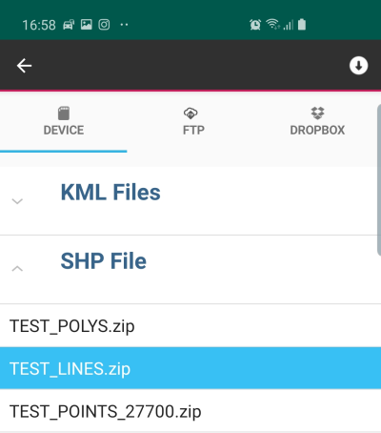

Alternatively, to the local import - users can also use FTP/SFTP or dropbox. The import process is exactly the same as described above, however necessary connection parameters must be set in Settings→Remote Connections for FTP/SFTP, in case of dropbox you need to authorise the app to use your dropbox account.

In case the connections are not set you can use “FTP Settings” or “Connect to dropbox” buttons to be taken to the right area of the application settings.

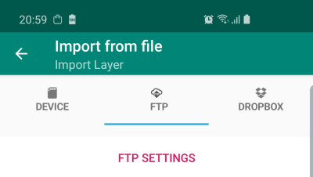 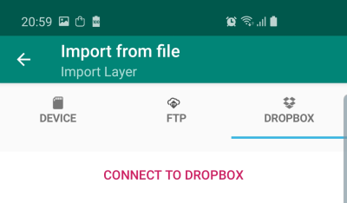

The application does not have access to all your files. If you want to import your data, after the account has been linked please place your files in   
**My files→Apps→Mapit Spatial** folder.

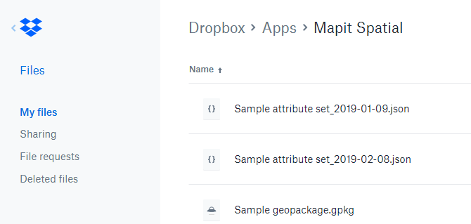

**Import data into existing layer – Geometry only**

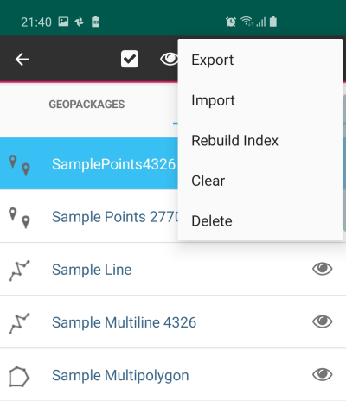 Apart from the option of importing the complete GIS layer (geometry and attributes), which effectively creates new spatial table in the GeoPackage database, Mapit Spatial can also import additional geometries into existing database table (layer). It does not matter if the layer is empty or not – the original GeoPackage table structure will be maintain, but new records will be created for all the features from import file.

To use this option please select the layer you want to import into than please chose “Import” option from the layer’s context menu.

The rest of the import process is exactly the same as described above (p.25)

The difference is that after the import you will not see any new layer on the list, but the geometry data will be added to the chosen layer.

So, for example if there was a layer containing for example 50 polygon features, and you have carried out import from geojson containing 100 polygons – the new polygons will be appended and in fact after import your layer will contain 150 records.

Note: The attributes for the layer you are importing the data into can be completely different than the ones in the file you are importing from – the important fact is however that the geometry type for both is the same, so it will not be possible to import points from geojson file into polygon layer.

**Import data – Summary**

1. There are two types of import available – it is important to understand the difference between them (p.23)
2. When importing from shapefile, make sure the shapefile elements (dbf, prj, shp etc. are ZIP compressed and the name of the ZIP is exactly the same as the underlying files.

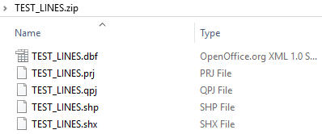

1. Supported formats for import:

* **Geojson**
* **Shapefile**
* **KML** (for import with attributes KML must contain so called Extended Data)
* **CSV** – POINTS Only – the layer must contain at least fields “lat”,”lon” alternatively “alt” and other attributes.
* **GPX** – tracks only

1. For local imports please place your files into Mapit-Spatial →Import folder on your device.
2. Generally imported data should be in WGS84 (EPSG: 4326), however import from geojson and shapefile can support projected data, however the information about the projection must be presented in the .prj file for shapefiles or included in the CRS property of geojson file.

**Layers’ Management**

To select the layer – please tap on the list element. The selected row will be highlighted in blue and the context menu will be displayed at the top of the screen.

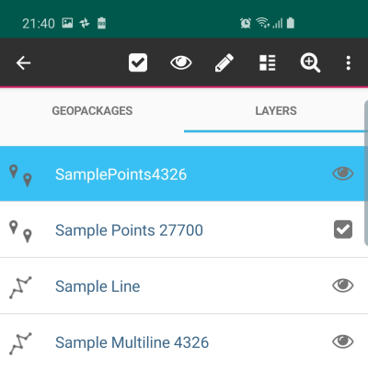

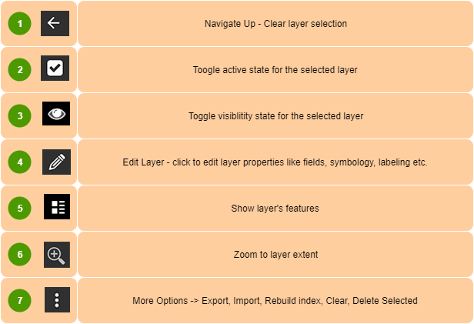



Standard Android „Navigate Up” button – when the layer is selected it clears out the selection and closes the context menu. If the layer is not selected it closes the „Layer Management” and user is navigated back to the map. The same effect can be achieved using Android “back” button.



To be able to add new features to the layer it is required to have an active layer.

The active layer automatically becomes visible on the map, even if the visibility is set to “none”.

Only one layer can have “active” status at a time – when you activate one layer if there was any other layer active before it will be deactivated automatically.

If you want to deactivate a layer and do not make another layer active – please select the active layer and press “change active status” menu item ones again.

The information about current active layer is displayed on the status bar as shown on the pictures below:

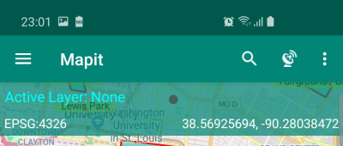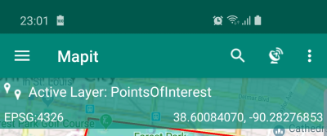

**TIP**: To quickly swap the active layer, please tap the current active layer name in the “Status bar” – this will open standard “Layers” tab in the Geopackages section.

  
  
If there is a need to temporarily hide some layers on the map users can easily change the visibility state for each layer – to change layer visibility, select the layer then press the “eye” item on the context menu. Active layer is always visible.

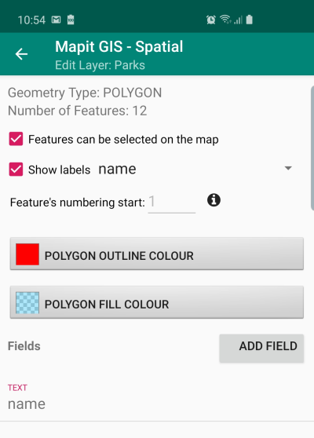

It is more than likely that you will need to edit some layer properties before you start using it in your projects. The common things changed are the layer symbology, labelling of the features and the layer fields. Ability to add fields and optionally linking database fields with the attribute set makes Mapit a powerful and flexible tool, which can be adopted to number of projects and support different workflows and user needs.

When you start editing of the layer you will be presented with the screen similar to the one on the picture on the left.

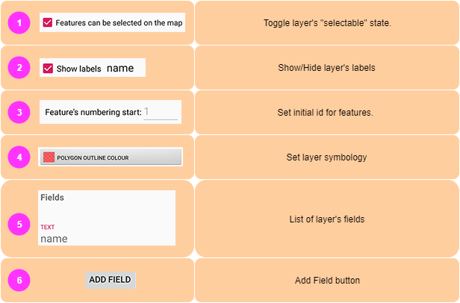



On some occasions, you want to display the vector data only as a form of background mapping and you do not need really to interact with the layer in any other way. If this is a case you can simply block a layer using this switch and get it excluded from the possibility of being selected on the map. This function is also useful when you work with multiple vector layers and would like to keep a map „clean” in terms of selection. Sometimes – when layers do overlap, it can be challenging to get the proper feature selected and this function can be utilised to manage the „selectable” state.



Please use this option if you want the labels displayed on the map. The label can be generated from any field value, to specify the field used for labelling please select it from the dropdown as shown below.

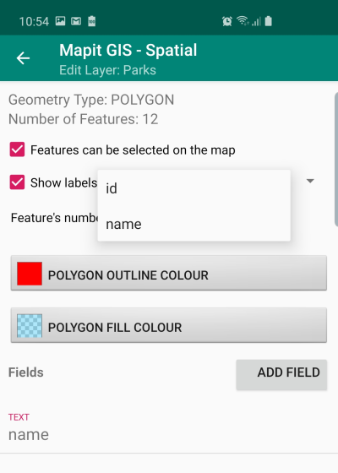



If there is a need to start numbering of the features from e.g. 100 instead of 1 - it can set this here. This option can be useful if for example you are carrying on a survey and export the data to PostgreSQL database, you can for example export 99 records and create new table in Postgres during first export, then you may clear the layer in Mapit and set this value to 100. The next export to Postgres will utilise „append” method and newly created records contain continues ids.



You can use this option only when the layer is empty – so is just created or emptied using „clear” option (this will be explained later).

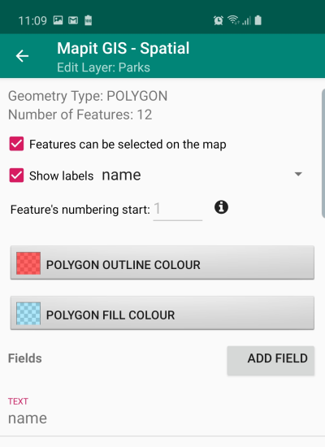  
For every layer user can specify the display style. The symbology can be changed at any time. For polygons there is an option allowing to set separate colour for the polygon outline and separate colour for polygon fill. You can also set transparency level for the polygon fill using the slider on the „set colour” dialog.

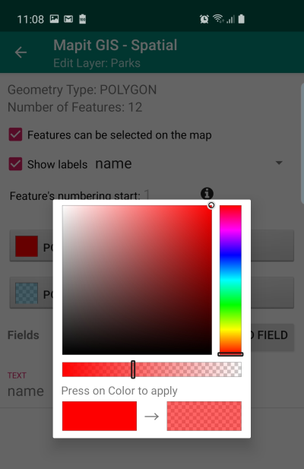

To apply the chosen colour – please tap the colour rectangle in the bottom-right corner of the dialog box.

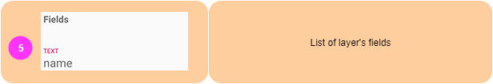

As we have mentioned before, in Mapit Spatial the layer is simply the database table in GeoPackage database. Apart from the geometry (which is a native feature) of any GIS layer – users can define set of fields, which will be holding the attributes data.

Each layer can have their own set of fields – each field will be displayed than on the data entry form allowing users to record specific pieces of information for each entity in the table.

Fields can be created in Mapit directly, you can also prepare the data layers in desktop GIS like qGIS, alternatively you can import the layer with attributes from file like geojson or shapefile.

All layer’s fields are displayed in the list below „set colour” section of „Edit Layer” screen.

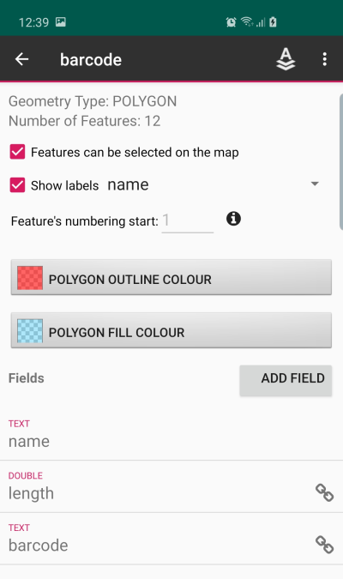In the example on the left the layer contains 3 fields.

**name** – data type TEXT

**length** – data type DOUBLE

**barcode** – data type TEXT

****The chain icon on the right means that field is linked to the attribute set (this functionality will be explained later in the guide).

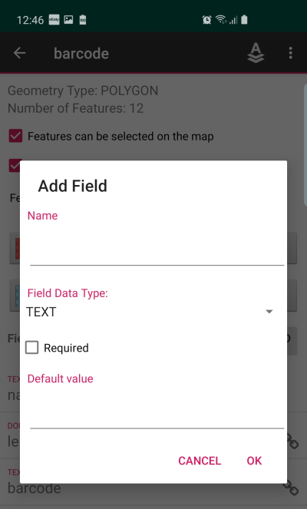  
  
To add a field please press the button „ADD FIELD”. Following dialog box will be displayed:  
Parameter „Name” is required and you need to populate a name to be able to save new field.

**TIP**: Please try to keep your field name simple and avoid any special characters like local diacritic symbols if possible.

In the next step users have the option to set a field data type. If you want to keep your field as a general text and be flexible in terms of entry you can leave it as TEXT, however if you want to be more specific in terms of data type following types are available:

TEXT – this field can store any type of text information, you can use it also for storing numbers, however after export you will not be able to do e.g. any arithmetic operations on this kind of values.

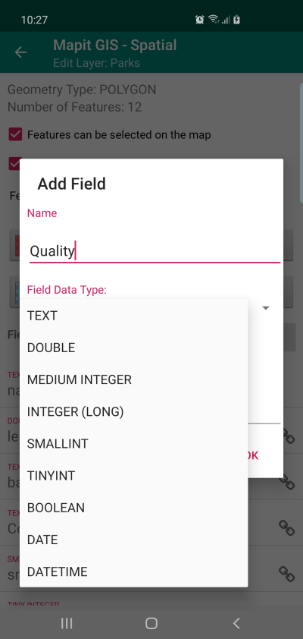Following Numeric fields are dedicated for storing numbers:

**DOUBLE** – can store any numeric entry including decimal values

**MEDIUM INTEGER** – integers in rage (-/+) 2147483647

**INTEGER (LONG)** – integers in range (-/+) 9223372036854775807

**SMALLINT –** integers in range (-/+) 32767

**TINYINT –** integers in range (-/+) 127

**\*BOOLEAN** – please use this if you want to gather information like YES or NO

**\*DATE** – use this data type if you need to collect date related information

**\*DATETIME** – as above, but you will be able to store also time information.

*relevant widget (calendar or date time) or (yes, no) dropdown list are generated automatically for these data types.

During the “Add Field” operation you can also choose that the field will be required – in this case the default value must be provided.

The required field is having a “star” symbol just before its name – please have a look at the Colour field below.

When you add new features on the map – the required field will be automatically populated on the data entry form with the default value.

To finalise “Add Field” operation please press “OK” on the dialog box – the new field will be added to the list of entries for the selected layer.

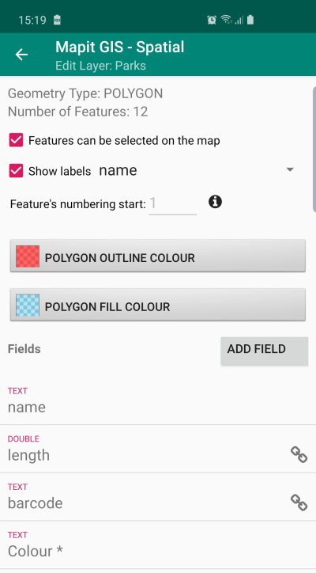

**NOTE**: All fields are immediately available on the entry form as free entry TEXT BOX or in case of Boolean YES/NO dropdown-list or alternatively CALENDAR or DATE TIME widgets for date or date time datatype.

To create however more sophisticated forms – utilising predefined dropdown lists, barcode scanner or multi selection lists you must utilise so called “Attribute Set” link.

**Field options**

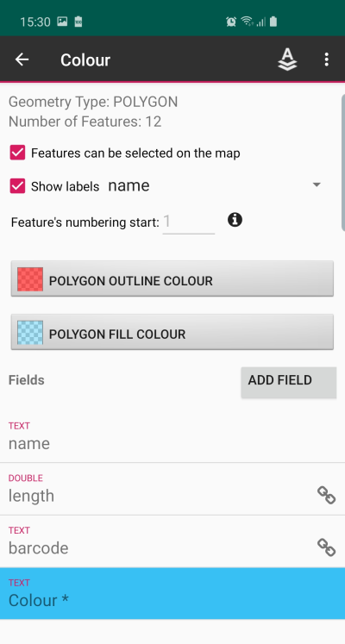When the field is selected – it gets highlighted in blue as shown on the picture on the left.

The name of the selected field appears also in the title of the context menu and field related menu items appears on the toolbar.

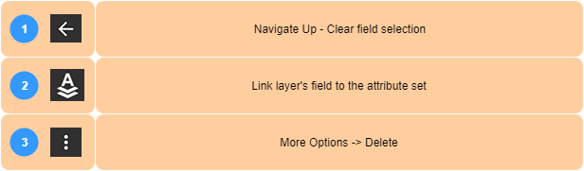



Press this icon or Android “back” button to clear the field selection end get back to “edit Layer” screen.



This option is being used to link the database field of the layer with the pre-defined attribute set. More information about the attribute sets management will be provided later in the guide. When the item is selected from the menu, following dialog box is being displayed:

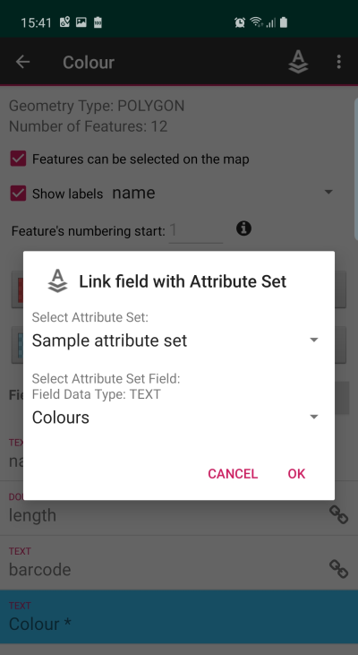

It is worth to say that in Mapit Spatial you need to link the field only if you want to use following features:

**Predefined list of values** – displayed on the entry form as dropdown lists.

**Multi selection lists of values** – allowing to pick up one or more values from the list.

**QR and Barcode scanner** – this allows users to open a barcode scanner directly from the entry form and get the value scanned directly into the field.

Linking the database field with Attribute Set field is very simple – you just select the relevant attribute set and the defined list for colours.

**NOTE**: The important thing to remember when linking the fields is that the data type must match so for example if you are linking a DOUBLE database field – the attribute set field must be DOUBLE as well.

**TIP**: To use barcode scanner please set the database field type as TEXT.

If the data type of the database (layer) field matches the attribute set type – please press “OK” on the dialog to finalise the linking operation.

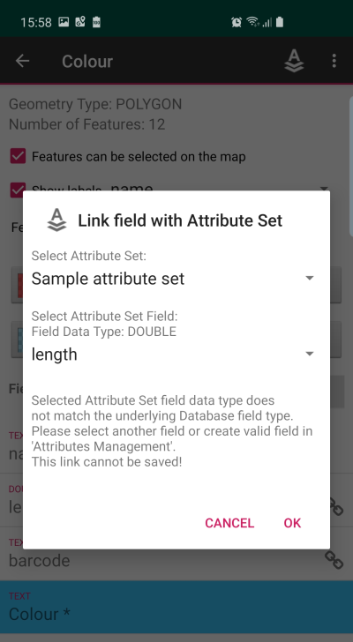In case the data types for the fields does not match the relevant information will be displayed – below example when we are trying to link layer’s field of type TEXT with the attribute set of type DOUBLE.

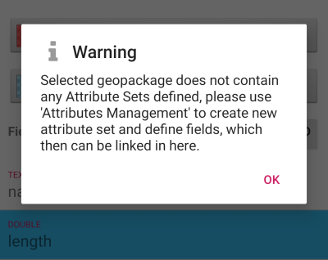If the selected GeoPackage does not contain any attribute sets yet following message will be displayed:

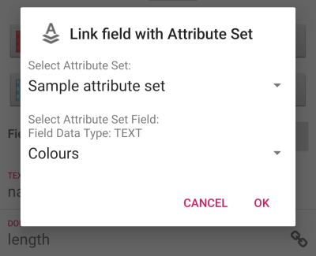When the data type for both database (layer) and attribute set fields matches, after pressing “OK” the fields will be linked and the chain icon will be displayed next to the field and when adding new feature, the dropdown list will be displayed.

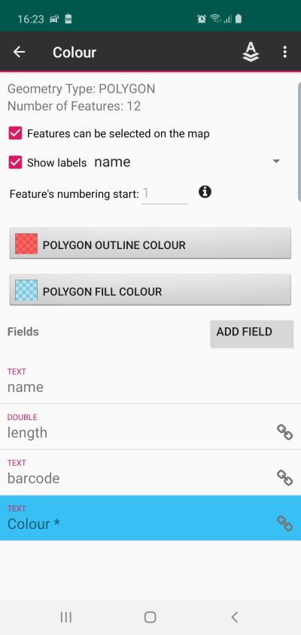 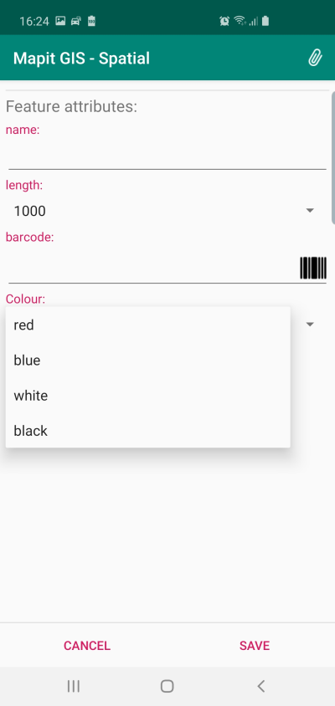

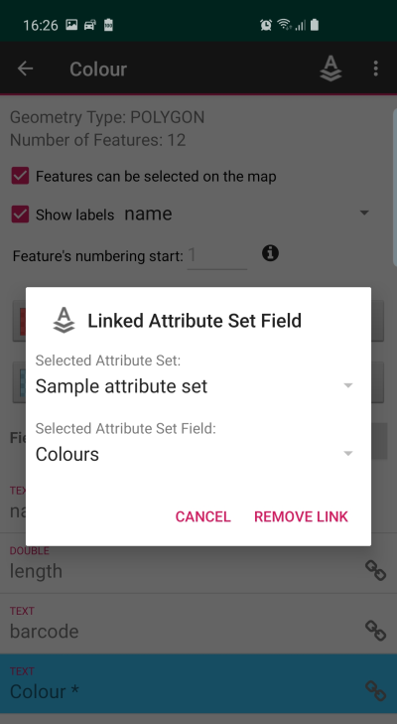If you would like to remove existing field link please select already linked field – containing the chain symbol.

The dialog as showed on the left will be displayed.  
  
Please press “REMOVE LINK” button to proceed.



To remove selected field please select it from the list than use “Delete” option from the context menu.

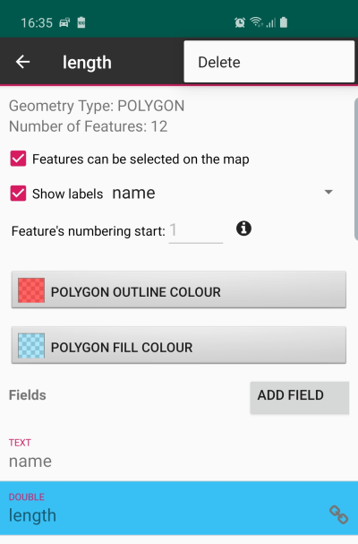

**NOTE**: The field name cannot be changed – if you need to correct field name it must be removed and added one more time. Please note that whatever information was already collected for that field will be removed with it as well.



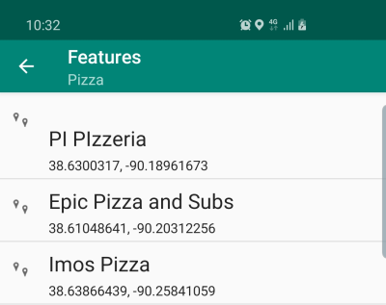Please use this option to display list of all features recorded for the layer.

For point layers the geographic coordinates in form lat, lon are also displayed. To select the list item, please tap it and the context menu will appear at the top of the screen.

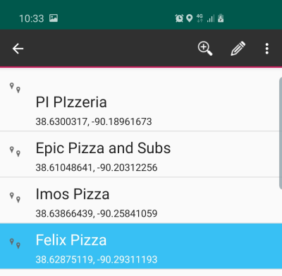

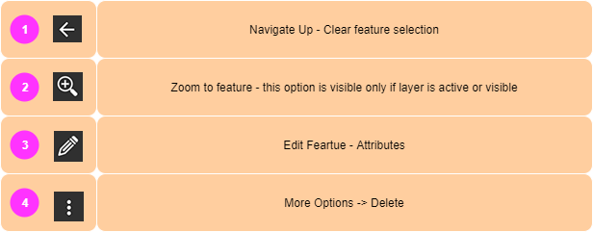

  
Press this menu item or device “back” button to navigate up to “Layers management” section.

  
Please note: This option is only available for active or visible layers.

Please click this option to get back to the map. The map bounds will be set to match selected feature extent, or centred at the point feature in case of POINT data.

  
Please select this option to edit the feature’s attributes. The “data entry” form will be displayed. This is equivalent to the selection of the object on the map and “info window” click operation.



Please select this option than “Delete” to remove the feature from the layer. Warning dialog will be displayed asking for confirmation.

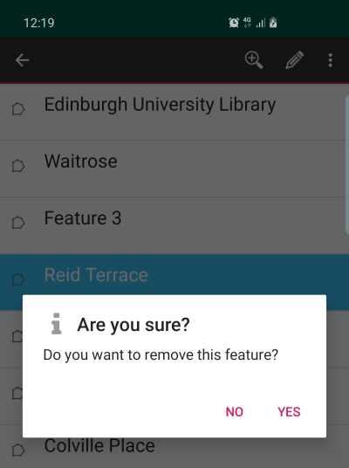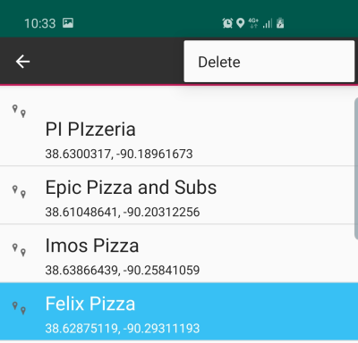



This option is available only for active and visible layers. This function relies on the spatial indexing and proper extent for indexed features. If this option is not working as expected for you please see “Rebuild index” option described below.



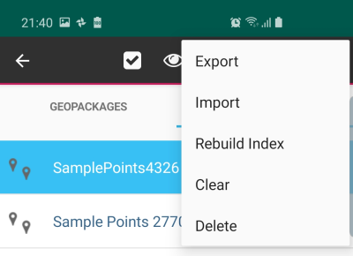  
Please select this option on the menu to see additional options available for selected layer.

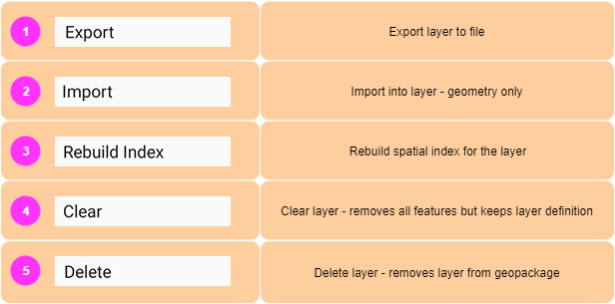



Export menu item allows users to export

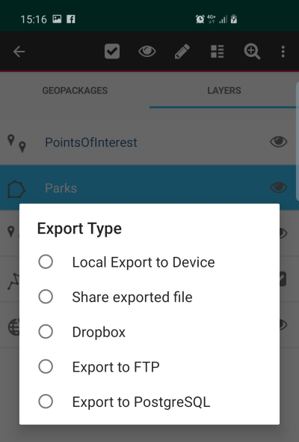Layer can be exported to number of widely recognised formats like geojson, shapefile, kml, dxf, gpx or csv. Direct export to Postgres database is also available. When the Export item is clicked following dialog will be displayed – asking user to choose the export location.

* **Local Export to Device** – the exported data will be saved on internal device memory in Mapit-Spatial → Export folder.
* 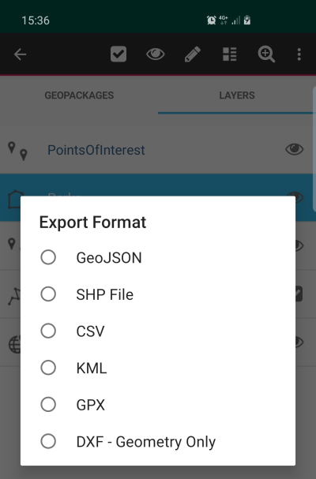**Share exported file** – this option will open the default Android share application allowing users to share the data via applications like Gmail, WhatsApp, Messenger etc.
* **Dropbox** - please use this option to export your data to dropbox platform. Make sure your dropbox account is connected in Settings → Cloud Accounts.
* **Export to FTP/SFTP** – please make sure the connection details to the remote server are set in Settings → Remote Connections section.

For the above 4 types of export the dialog on the left is displayed allowing users to choose the required format of the file.

In case of direct export to PostgreSQL database there are 2 options available:

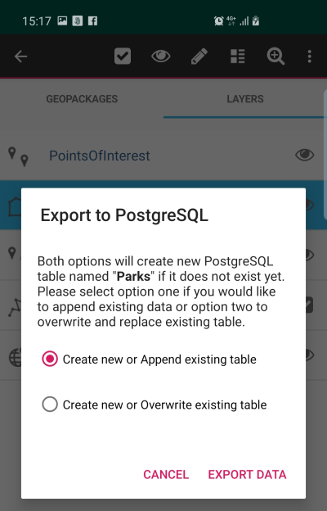

* **Create new or Append existing table** - this option will create new table if table does not exist or **append** the data in case table with export name already exists.
* **Create new or Overwrite existing table** – this option will create new table if table does not exist in the database or **overwrite** existing data in case the table with export name already exists.

**NOTE**: Export to PostgreSQL does require Internet connection. If you try to export the data to local server in your private network, but the database server is not exposed to Internet – the export will fail. During the export to PostgreSQL the data is first posted to the Mapit API which is preparing the data and executing the GDAL scripts uploading the data to your PostgreSQL database.



The import was already described on page 24 of this guide. This particular Import function is related to the import type described on page 27 – this import type does import only geometry into existing layer.

NOTE: The imported geometry type and geometry type of the layer you are importing into must match, so you can import POINTS only to POINT layer etc.

Imported geometries will be appended to the existing layer’s records.



In some rare cases you may notice that the “zoom to layer” is not working as expected or you miss some data on the map – please use this function to rebuild spatial index for the layer. This index is being utilised to optimise the drawing on the map.

In general, spatial index is self-maintained by the application – however if you experience some issues related to drawing of the features on the map you may use this function to get the problems resolved.

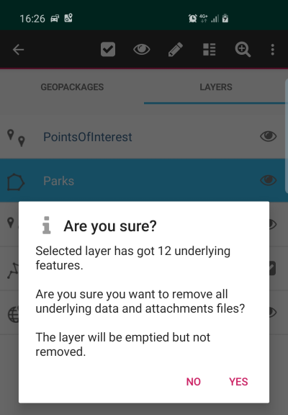

This option allows to clear the layer – removes all the features from the layer but keeps the layer definition, field links, symbology etc.

This can be useful in number of applications for example surveying similar items in different location or if you are utilising the export to Postgres append function and would like to avoid record duplications – this can be combined with the “set numbering start” option etc.  
We are sure users will find a dozen of other application for this functionality.

**NOTE**: This operation cannot be reversed and all the data will be lost if it was not previously exported.



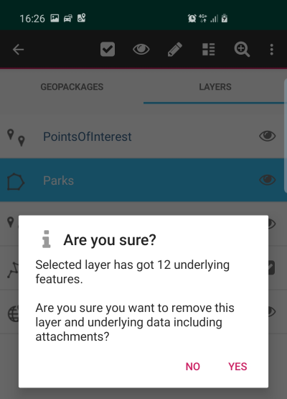This function will remove the layer completely from GeoPackage database.

**NOTE**: This operation cannot be reversed and all the data will be lost if it was not previously exported.

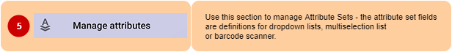

The concept of the Attribute Sets came from the fact that some information is very often entered multiple times during the surveys. So for example if there was a need of gathering information about the colours of the cars parked along the streets – instead of typing the colour names each time you open the form – you would probably prefer to have a predefined list of colours and when entering the data you would simply chose required value from the dropdown list.

Utilising the functionality described above – you can also make your data more consistent, typos free and better structured and you can achieve this simply linking your layer field with the attribute set field.

In Mapit Spatial you need to use attribute set in 3 cases:

* **To create dropdown list of predefined values**
* **To create multi-selection list of predefined values**
* **To utilise barcode and QR scanner for the TEXT field**

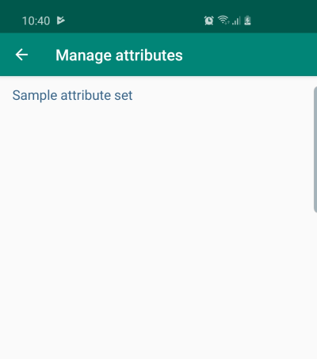When the app is installed you may notice there is a single attribute set, containing some sample fields. In the bottom-right corner of the screen there are 2 buttons available.



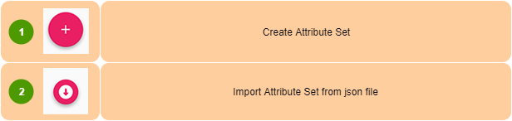



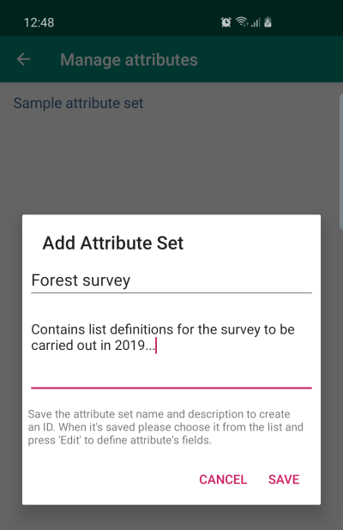

To create new attribuute set please press the + button – than provide the name or optionally description for the new attribute set.

Press “SAVE to finalise. New attribute set will be displayed on the list.

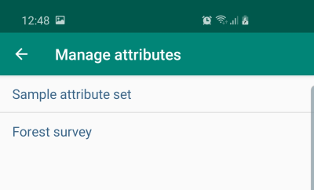

When the attribute set is selected it gets highlighted in blue and context menu apears.

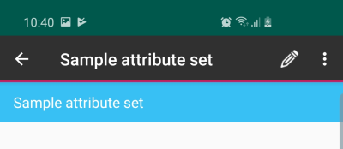

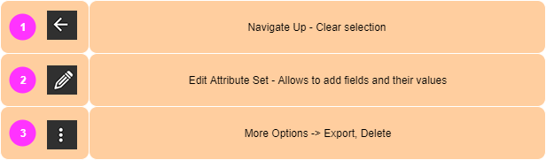



Navigate up, clear the list selection.



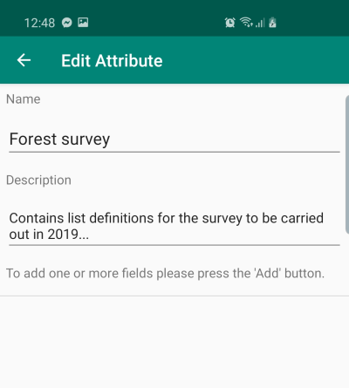By editing the attribute set, you can add fields and add values to each field. These fields can be then linked with the layer’s fields and finally you can add the data on the data entry form using predefined lists of values.

Please tap the button to add new field and its values.

When you press the ‘Add’ button following screen will be displayed:

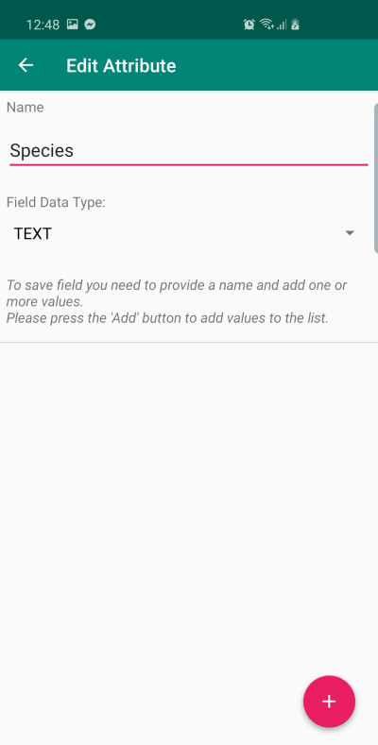You need to provide the name for new field – in our case this is “Species”.

You need also specify the data type for the field – **this is important step as the attribute set field data type must match the data type of the field you want to link in the layer.**

So, assuming we have a layer containing field “species_name” in the layer of type TEXT, we are going to create the field “Species” of type TEXT in the attribute set and we will populate it with some trees name values.

These values will be then displayed as options for selection in the dropdown list on the data entry form.

Press the to add some values:

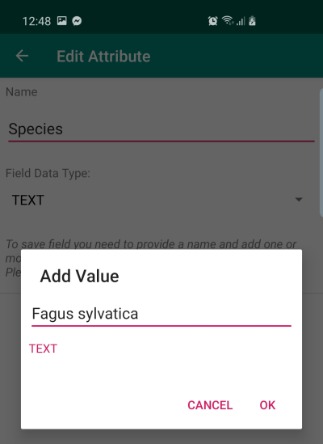 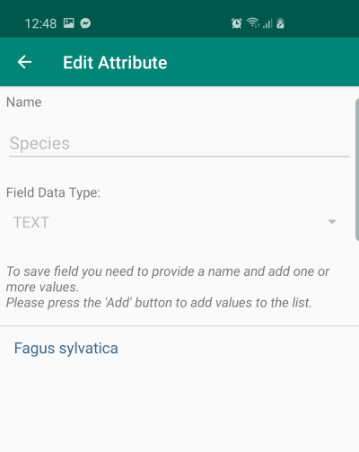 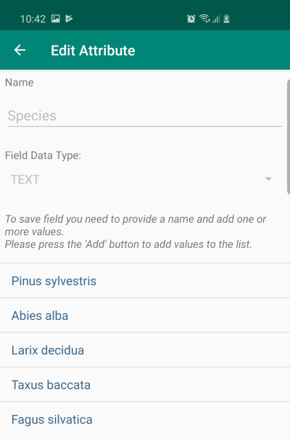

Please repeat the process to populate all required values.

Now you can get back one level and add other fields and their values.

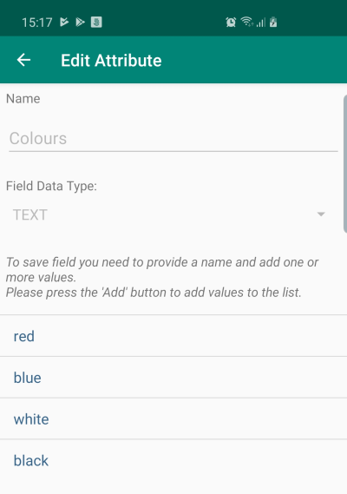 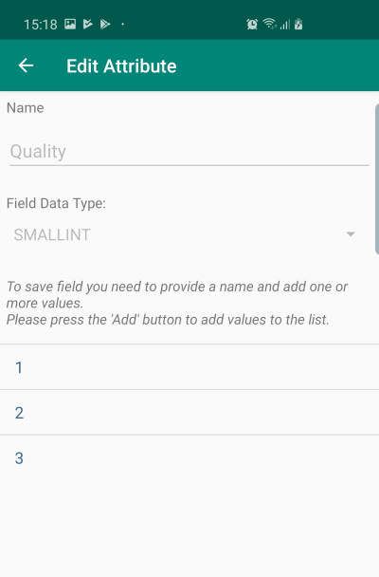

**Single choice dropdown lists**

This kind of lists allows selection of the value from pre-defined list of values. They are defined in the attribute set. You can create single choice dropdown list for any type of the data like TEXT, DOUBLE and INTEGERs.

The process is simple, the field must be added to the attribute set as described on page 52 and the values populated for that field according to page 53. The final action is the “link field” operation on the “Edit Layer” screen – page 39.

Following the above when user creates new feature on the map – on the data entry screen the dropdown list will be created for the linked field as shown below.

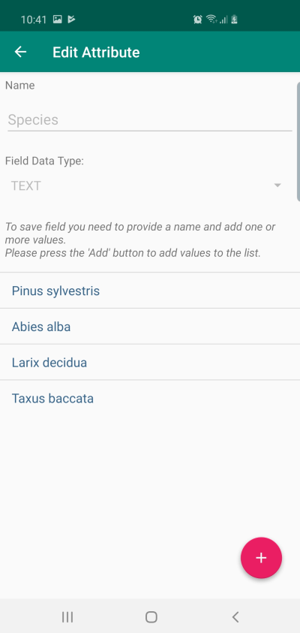 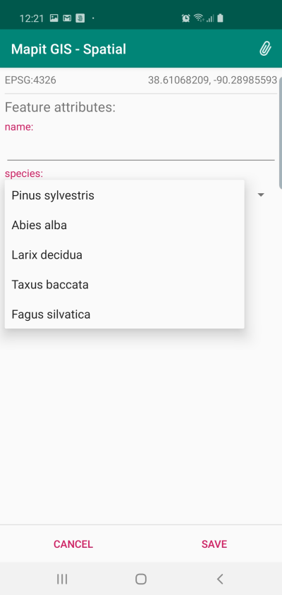

**Multiselection lists**

Multiselection list allows users to select one or more options from the predefined list of values.

To create such list please select MULTISELECT in the field data type dropdown when adding the Attribute Set Field and then add some values.

You can link any layer field of type TEXT with the MULTISELECT list and it will be available on the data entry form as displayed below.

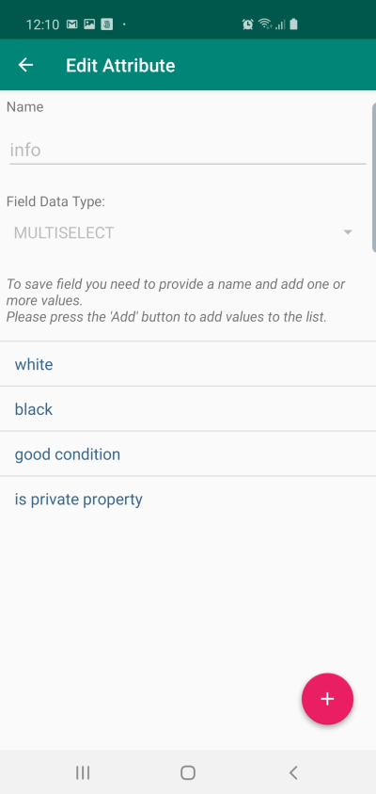 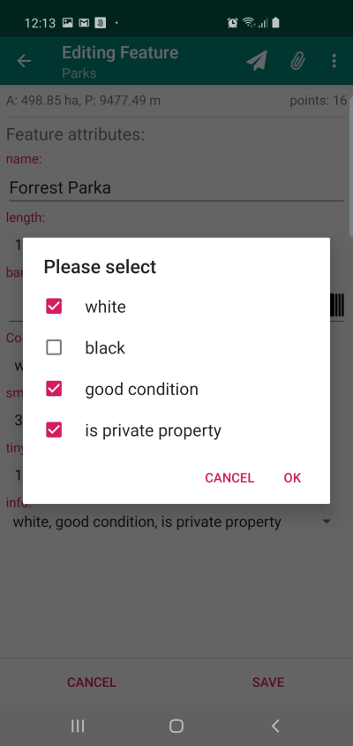

**Barcode scanner**

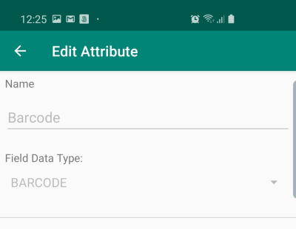If you intended to utilise a barcode scanner (it is built in in the Mapit application – and it does not require any external scanners attached) – you need to define the Attribute Set field of type BARCODE.

The barcode field can be linked with any field of type TEXT.

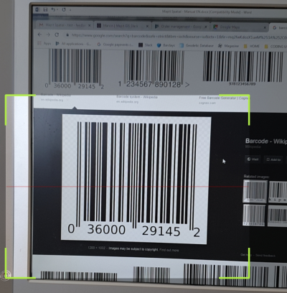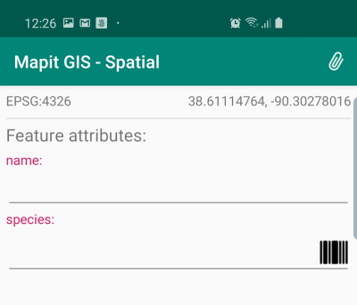On the data entry form on the right had side of the text box you will see the little “barcode” icon – please press it to open the scanner and scan the value.



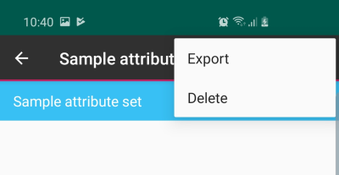To remove the attribute set, please select it from the list than choose Delete from the context menu. You cannot delete attribute set when it contains fields defined and relevant warning will be displayed if this is the case.

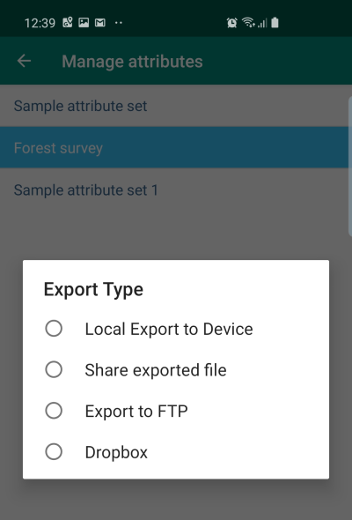Attribute Set is stored in GeoPackage database, if you would like to use the same attribute set in different GeoPackage – please use Export function. The quickest option is to do Local Export – **that way exported attribute set is immediately available for import from another GeoPackage.**

If you want to share your attribute set with other users or store it in the cloud like dropbox, so you can access it anywhere – please choose relevant option to do so.

The files are exported as a simple text files (can be edited with any text editor) and the content is standard JSON structure.

{

"name": "Sample attribute set",  
 "description": "",  
 "fields": [

{

"name": "Species",  
 "dataType": "TEXT",  
 "defaultValue": "",  
 "values": [

"Pinus sylvestris",  
 "Abies alba",  
 "Larix decidua",  
 "Taxus baccata"

]

},

{

"name": "Barcode",  
 "dataType": "BARCODE"

},

{

"name": "length",  
 "dataType": "DOUBLE",  
 "defaultValue": "",

"values": [

"1000",  
 "1250",  
 "1500"

]

}

]

}

**NOTE**: Mapit Spatial – attribute set files can be also created using external editor, so for example instead of creating long species list on the device, users can prepare the files on PC and then get them imported.

It is recommended however that you pre create fields and then export the structure to manipulate it further if required.



**Import attribute set**

You can import exported locally files immediately to another GeoPackage or alternatively you can create the files in any text editor on the PC and then please them in **Mapit-Spatial → AttributeSets** folder.

The important thing is that the extension of the files is .json - otherwise they will not be displayed on the import screen.

To import the attribute set from file please press the import icon.

Following screen will open allowing to choose the import location.

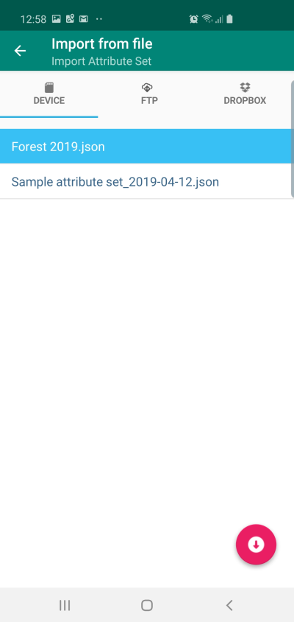Select the file (it will get highlighted in blue) – than press the import icon in the bottom-right part of the screen.

  
This function allows to search for places and addresses and is using Nominatim search engine [https://nominatim.openstreetmap.org]. This function can also be utilised to centre the map on the latitude, longitude location.

To centre on location please enter coordinates e.g. 55.8629429,-4.2349042 to centre the map on Glasgow Cathedral.



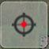Press this menu item to get detailed information about current GPS position. When using internal GPS, you need to make sure you have got the “Centre on GPS” option on.

Sample GPS Info screen looks like on the picture below. To close it down you can press the “GPS Info” button again or swap the screen up.

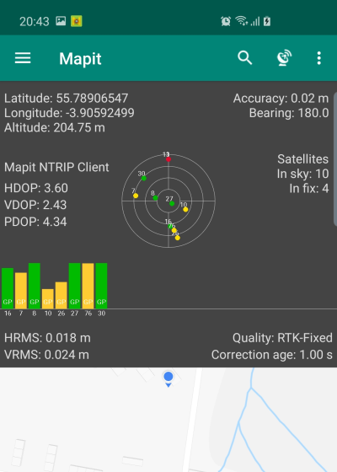**NOTE**: Not all information is always available. Some readings like RMS values, correction station ID etc. are available only for some types of external GNSS devices connected to the application.

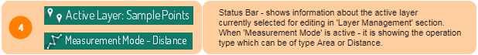

The “Status Bar” role is to provide information about the current app mode.

When you are in the “Survey” mode – you can see information about the currently selected “active” layer. The “active” layer is the one you can add new feature into and the “active” status can be set in Layer Management section. You can access it from navigation drawer -> Geopackages ->Layers or you can click the name of the active layer on the status bar to be taken to the “Layers” screen directly.

If you are in the “Measurement” mode – you can enable this with the start measurement button the “Status Bar” will display the relevant information.

**TIP**: To swap between “DISTANCE” and “AREA” in measurement mode – **long press** the measurement button.

To exit from “quick measurement” mode just press the button again.

More information about the measurement mode will be provided further down in this guide.

  
This element holds information about currently selected spatial reference.

Most users works in WGS84 (EPSG: 4326) coordinate system (and it is set as default when you start working with the application), however if there is a need to use local projected coordinate system like e.g. British National Grid (EPSG: 27700) – this is possible and can be set in Settings->Units & Coordinates section.

NOTE: 3rd party prj4 library is being used to convert coordinates and some projections may not be supported.

When you try to use custom EPSG code, but it gets reset back to EPSG: 4326 it means that this particular projection is not yet supported.



Mapit Spatial is having two states.

**Centre on GPS** – when red dot is displayed on the switch – that means the device is trying to utilise the GPS position (This can be either internal or external GPS). When the GPS position is available the map will be automatically centred on the current location.

**Map Cursor** – when you would like to create new features based on the map information like digitising a river or piece of land from the aerial photography – you can switch off the “Centre on GPS” and utilise a map cursor (cross in the centre of the map) to add new points or varices to constrict the features.



Depending from the mode you are in “Centre on GPS” or “Map Cursor” in the centre of the map there is so called “blue dot” or “crosshair” displayed.

The “blue dot” is giving you as well the rough information about accuracy – when the area covered by “blue” is bigger – it means you are having a week and not very accurate GPS signal.



The scale bar can give quick estimation of the distance per map unit.

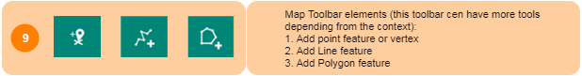

The “Map toolbar” is located in the lower-right part of the screen. Its content (menu items) changes and they depend from the context like geometry type of active layer, edit session state, feature selection etc.

**Add POINT feature or Vertex** The most common toolbar icon and you can see it whenever there is a need to insert a point or vertex (lines and polygons), you will see this in both measurement and editing mode. Depending from the **geometry type** of active layer the behaviour will be different after click.



* **POINT layers** - Depending if you are in “Centre on GPS” or “Map cursor” mode when you click a GPS location or the map centre coordinates will be used to construct new feature geometry. After the click a “**Data Entry Form**” will be displayed (see more details below).
* **LINE, POLYGON layers** – new vertex will be inserted, again a GPS position or map cursor coordinates will be used depending from the “Centre on GPS” state.

   
 **Add LINE feature** - this item is only visible when **LINE** layer is active.

**Add POLYGON feature** - this item is only visible when **POLYGON** layer is active.

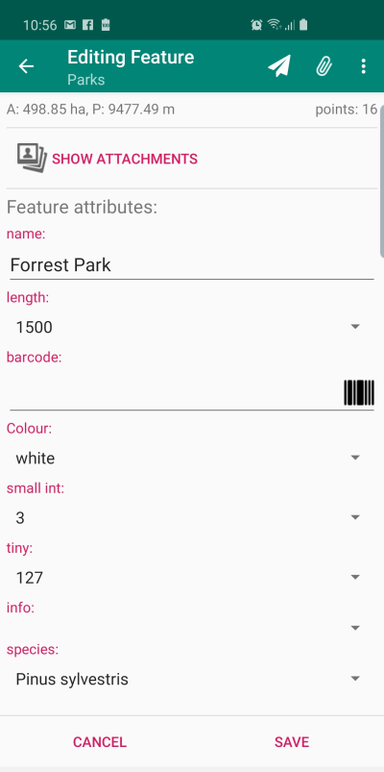**Data Entry Form**

When you create new feature in Mapit Spatial – (by clicking the menu items described above) first thing you need to do is to populate the attributes form. That way you will never miss or record the geometry without the data attached to it.

The data entry form is a representation of all the layer’s fields in forms of the free entry text boxes, alternatively when the layer’s fields are linked to the attribute set, relevant dropdown lists or other widgets will be displayed.

The data entry form context menu allows you as well to add some feature attachments like pictures, videos or audio recording.

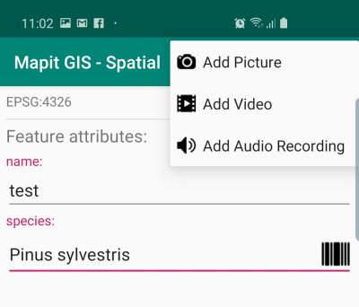**NOTE**: The attachments are not stored or saved within the layer (this is because the large size of the media files). They are stored in: **Mapit-Spatial →Attachments** folder and organised in folders representing the **GeoPackage->Layer Name→Feature ID**, so you can link attachments back to the data in post processing if required.

By pressing “SAVE” on the data entry form there could be 2 different behaviours observed:

* **POINT Layers** – the new feature is saved into the layer and is immediately visible on the map.
* **LINE and POLYGON Layers** - the new feature is saved into database but the geometry is empty, the next phase of the add line or polygon is started and you need to add vertices using the “Add vertex” button to see the line or polygon constructed on the map.

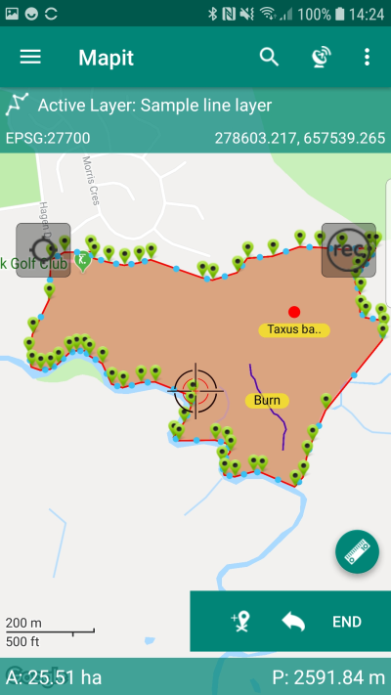

**Edit Session**

* The active edit session of LINE or POLYGON layer can be recognised by the presence of “END” item on the toolbar. In fact, the feature geometry is updated in the database every time you add or remove the vertex, but if you wish to exit the edit session please press the “END” button on the toolbar.
* GPS Tracking - When edit session is active – for LINE and POLYGON layers, you can also use automatic track recording – please press “rec” button to start the tracking service and to record the vertices automatically as you move. The tracking will also record new vertices if the app is in the background or the device screen is off.
* When track recording is active – the “rec” button colour changes to red.

**TIP**: Tracking parameters can be modified in Miscellaneous Settings.

In case you record a vertex by mistake or you want to remove one or few last vertices please use this button to do so. By pressing this button multiple times, you can reverse back to the beginning of the LINE or POLYGON.

By pressing this button, you will end the edit session and the polygon or line symbology will be reversed to layer’s default symbology applied in “Layers Management” section.

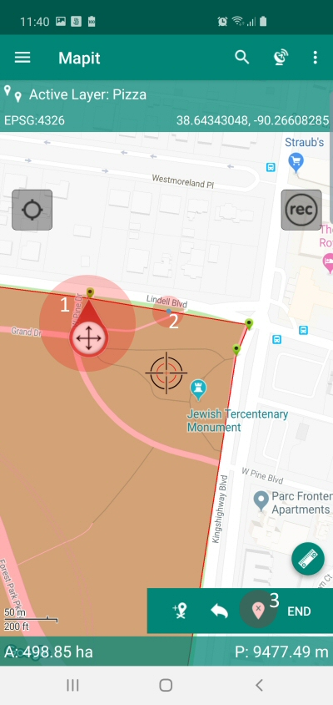

When the “Edit Session” is started, there are also three further actions available for LINES and POLYGONS:

1. When the vertex is selected on the map new menu item “Delete Selected Vertex” is shown on the toolbar. It is shown as 3 on the picture on the left-hand side.
2. Insert Vertex between existing vertices – please press the “Blue Dot” – shown on every polygon or line segment to insert new vertex in that position.
3. 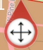 Move vertex – by pressing and holding this icon you can drag the vertex to another location on the map.

During the edit session relevant measurement is displayed at the bottom of the map, it can contain distance and bearing in case of LINES and area and perimeter in case of POLYGONS. The units can be changed in **Settings →Units & Coordinates section**.

The process above has been described for “new features” – however the edit session can be also started for existing elements currently presented on the map and this time this is not limited only to the “active layer”.

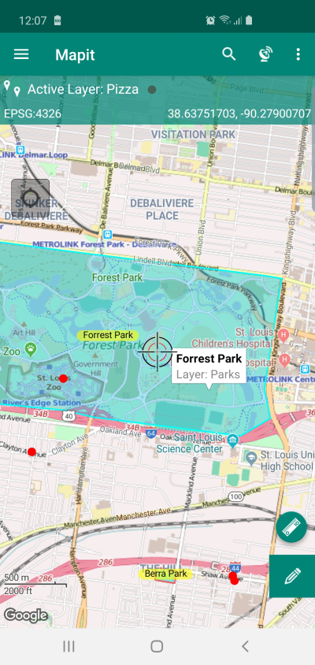To start edit session please select the feature on the map by taping its “yellow” label when available (must be enabled in Edit Layer section) or by taping the line or polygon geometry – when polygon, line or point is selected new menu item “a pencil” will be displayed, please press it to start edit session for selected element.

For LINE and POLYGONS standard edit session will begin after pressing the “pencil”.

For POINT features following screen allowing change of the coordinates will be displayed:

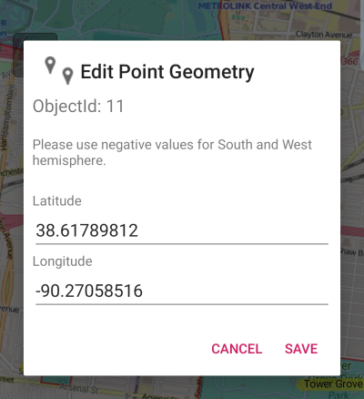

**TIP**: You can use “Edit Point Geometry” also if you need to add a point in a certain location. To do so please add a point feature anywhere on the map using “map cursor” than edit its coordinates using the dialog shown above.

**Distance & Bearing (Project Point) Method**

Project point method for adding points can be used in conjunction with any range finder which measures horizontal distance and true bearing to a target.

In the example below shows the construction of a line using the ‘Project Point Method’ but it can be used with any type of geometry type.

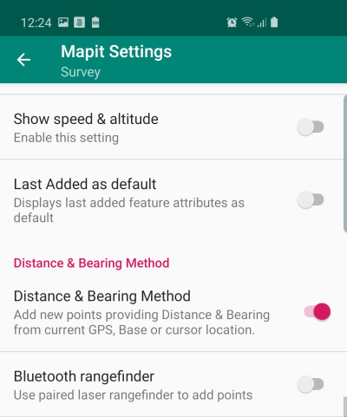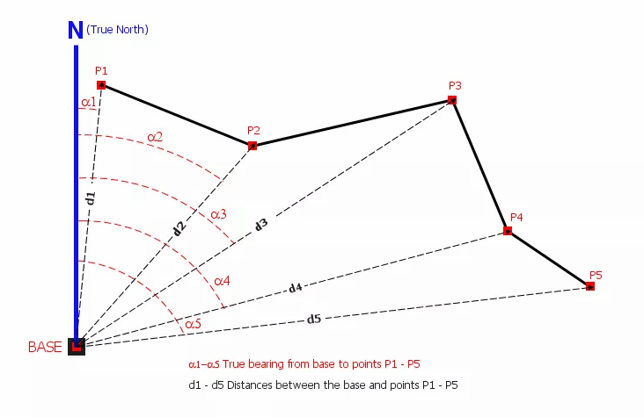

To be able to use the ‘Project Point’ method for add point action you need to go to ‘Survey Settings’ and switch on the ‘Distance & Bearing’ option.

When Distance & Bearing mode is enabled in the setting “Add Point/Vertex” tool will open a popup window where users can provide distance & bearing information (alternatively it can be read directly from the paired Bluetooth range finder).

Depending if you are in “Centre on GPS” or “Map cursor” mode the “Start from” option will be different as shown on the pictures below:

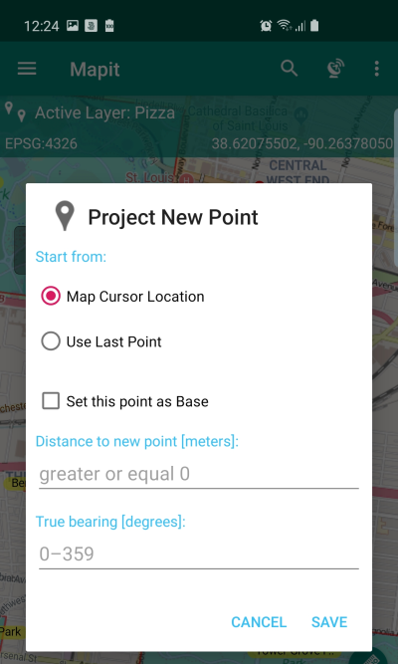 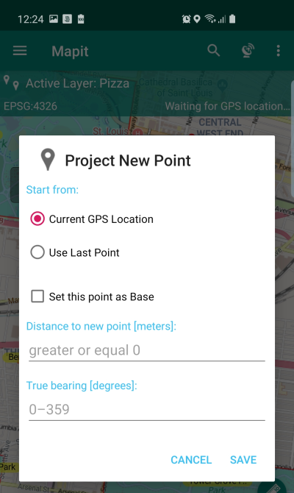

You can provide distance & bearing parameters manually or get them directly from the paired Bluetooth range finder.

Mapit Spatial been tested with 2 popular range finders:

           – **LTI True Pulse 360B Laser rangefinder**

Sample NMEA output for Horizontal Vector:   
$PLTIT,HV,3.70,M,165.90,D,-0.90,D,3.70,M*48

           – **Trimble LaserAce™ 1000  rangefinder**

Sample NMEA output for Horizontal Vector:   
$PTNLA,HV,2.94,M,288.1,D,8.6,D,2.98,M*5F

If your device supports Bluetooth connections and the output is consistent with NMEA standard you should be able to use it with MapIt – however this is not guaranteed.

Please follow the steps below to get MapIt properly connected to your rangefinder and use it as a distance & bearing source:

Make sure your measurement units on the rangefinder are set to M (meters) for distance and D (degrees) for angles.

Make sure the Bluetooth output contains HV (Horizontal Vector) data.

Make sure the rangefinder’s Bluetooth function is switched on and the device is paired to your Android Device.

Open Mapit Spatial and enable “Distance & Bearing” method for new points in ‘Survey Settings’.

When the ‘Distance & Bearing’ method is active you can now enable ‘Bluetooth rangefinder’ option. When enabling you will be asked to pick up the paired device. Please select the device you want to use as a source.

In the ‘Project New Point’ dialog box please select your start position and use the rangefinder to acquire a distance and bearing. If the distance and bearing fields are not immediately populated this is a sign that the rangefinder is not communicating with Mapit.

**Data entry screen – editing existing features**

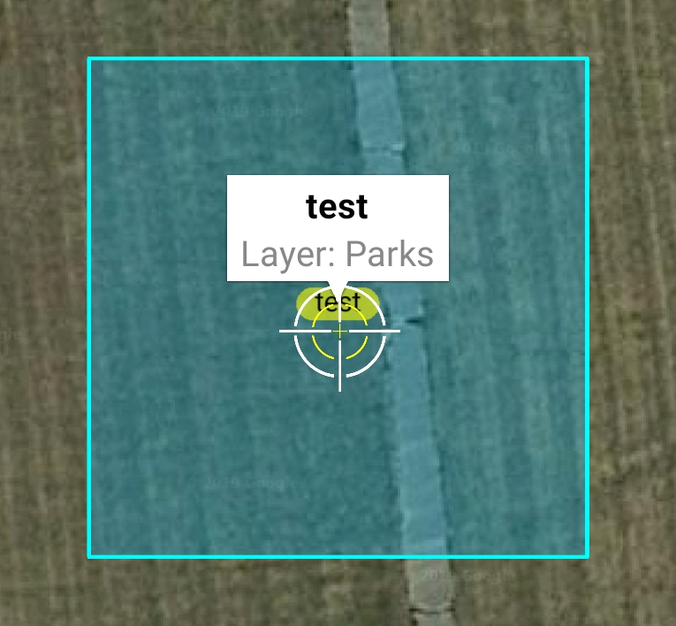In case you need to edit existing feature attributes and not geometry please select it on the map and tap the “info window” containing name & layer name – this will open the “data entry” screen.

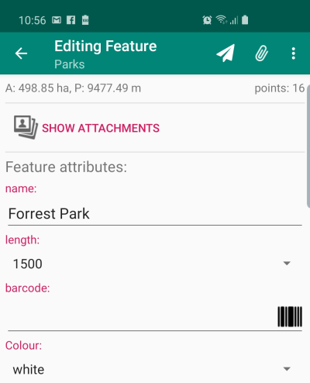Users are able to edit the data related to the features at any point.

On the context menu there are 2 more tools available:

Navigate to feature

More Options -> Delete feature

**Navigation to selected feature**

Use this tool on the “data entry” form (see page 68) if you would like to navigate to the selected feature. You need to have a GPS location enabled to use this feature.

When GPS location is established the line will be drawn on the map showing the shortest distance between your current location and the selected feature. In case of navigating to LINE or POLYGON the arrow on the map will be drawn between your current position and the nearest vertex.

To exit navigation mode – please press STOP.

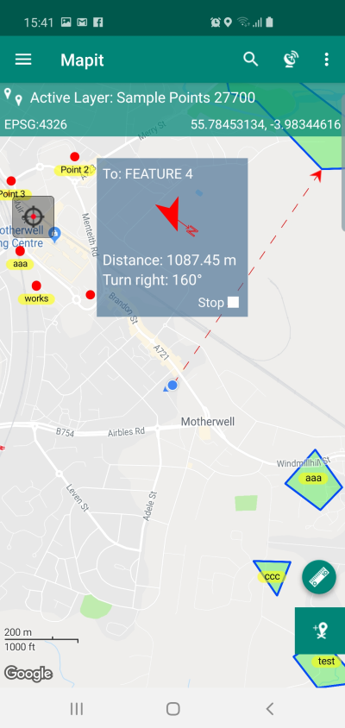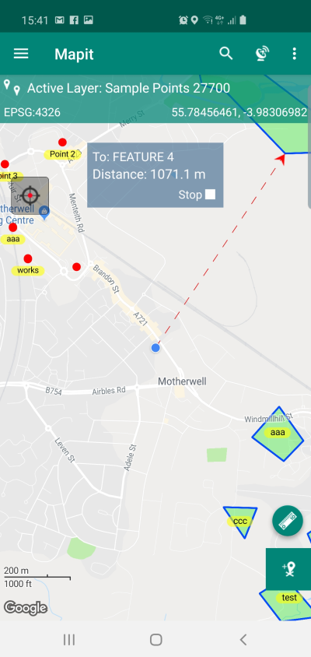In case the bearing information is available for the current GPS position there will be also navigation info displayed on the screen. The colour of the navigation arrow will be green if you are moving into the right direction than yellow and finally red when you are moving in opposite direction to the navigation object.



Measurement mode allows users to do quick measurements without the need of storing the data, so for example if you need to check what is the distance between point A and B or quickly calculate the area of the forest or any piece of land based on the aerial or satellite photos, then you can use this mode to do so.

Long press the “measurement button” to switch between DISTANCE and AREA.

After activating the measurement mode there is a message displayed on the bottom of the screen informing that you should start adding vertices.

Press the “Add Vertex” button to construct line or polygon.

The measurement mode can work in “Centre on GPS” or “Map cursor” mode.

The measurement details are being displayed on the bottom of the screen and the units can be changed in Settings**→**Units & Coordinates section.

To end the “Measurement mode” – please press the measurement button again.

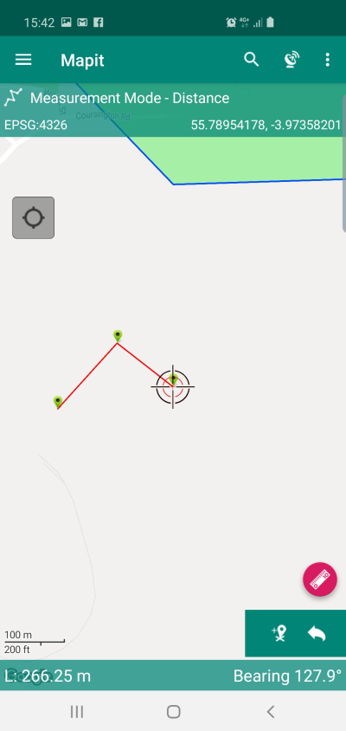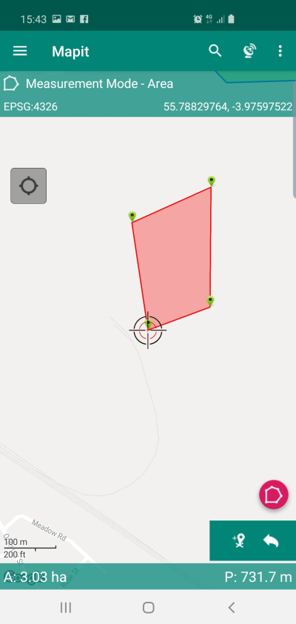



The map can be controlled by the standard gestures known from Google Maps, if you however prefer to have the zoom control on the map you can enable this in General Settings.

  
  
This view displays GPS position or map centre coordinates – depending if you are in “Centre on GPS” or “Map cursor” mode. Default latitude, longitude in decimal format are being displayed here, however if user has got custom coordinate system set in Settings**→**Units & coordinates the projected coordinates will be displayed here.

When you tap the coordinates view – the location details will be copied to the clipboard, so you can use them in other applications like text message when required.

  
Please tap the 3 dots (more options) menu item to get access to

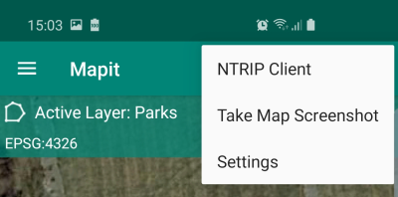

1. **NTRIP Client** – you can ignore this menu item if you are not using the NTRIP application.
2. **Take Map Screenshot** – use this option to quickly share the map content using standard Android share widget – only the map content will be shared and all buttons and layout elements will be removed.

The screenshots will be saved to the internal device memory and you can access them using standard Android Gallery application if required.

1. S**ettings** – use this option to open application settings.

**Application Settings**

Mapit Spatial application settings allows users to configure the app to the specific needs. You can hide or show certain elements of the UI like zoom control or set preferred measurement units and preferred coordinate system. The settings are split into some categories to simplify navigation.

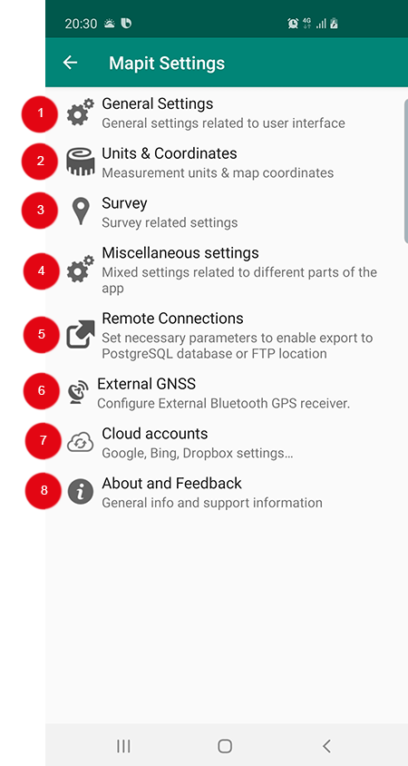



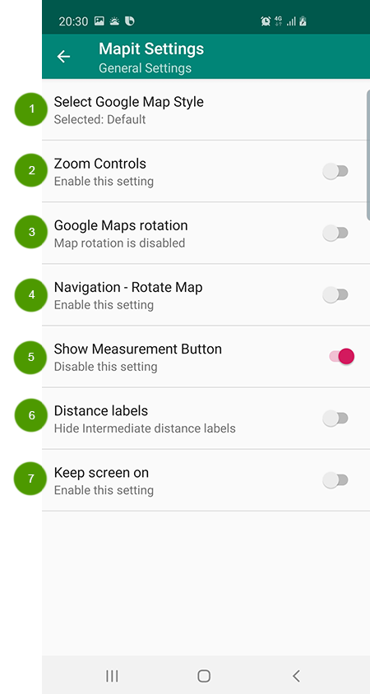

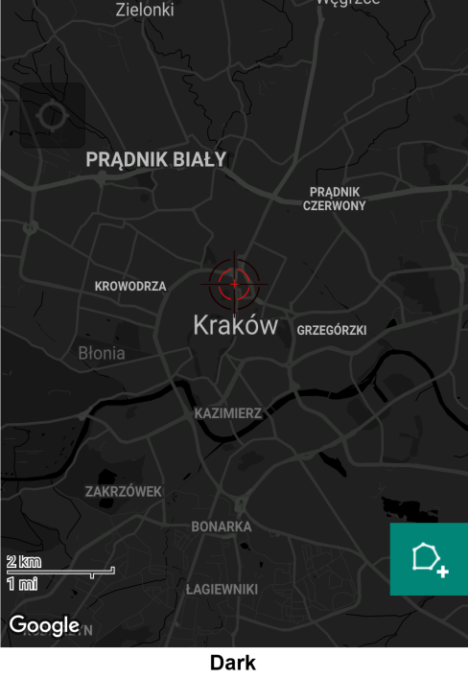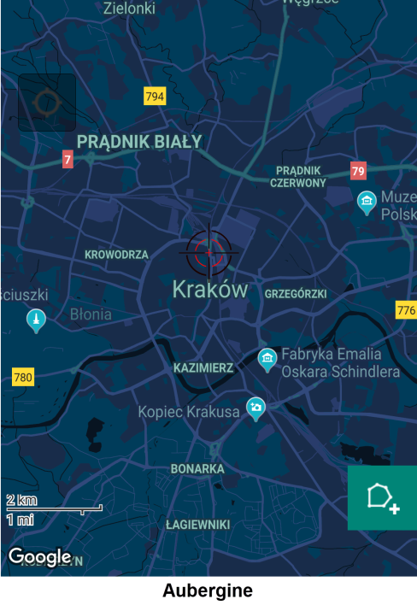

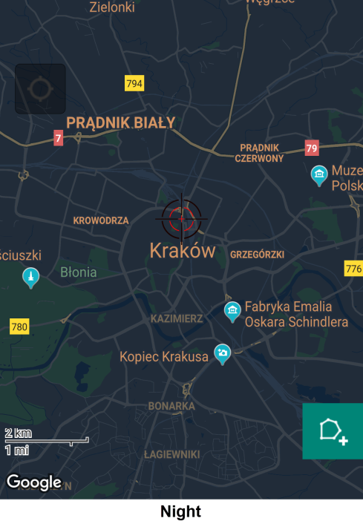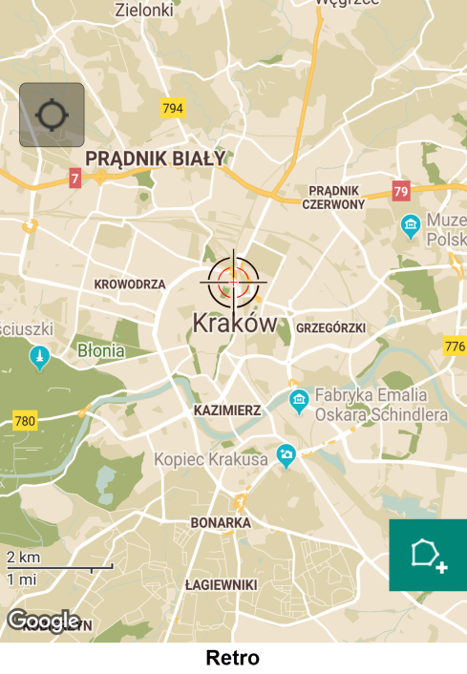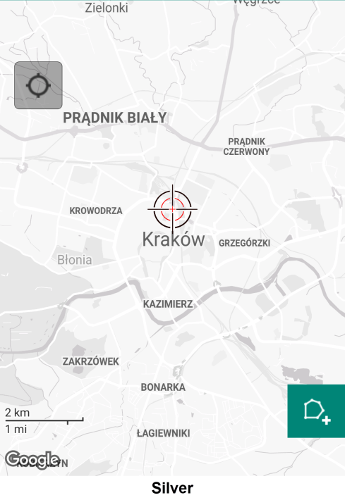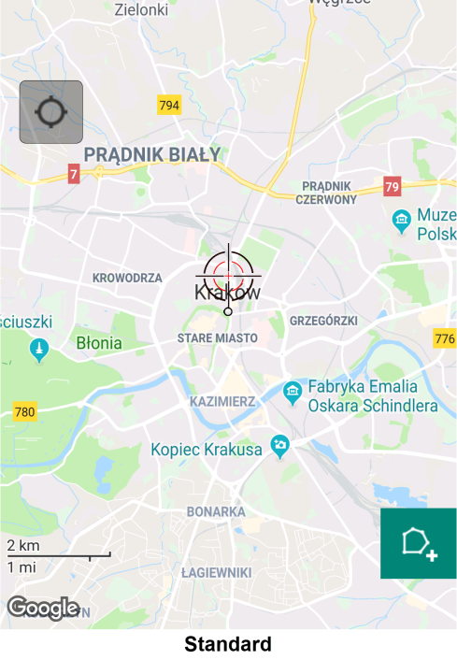

There is few map styles available as default, however users can defined their own styles using the designer at <https://mapstyle.withgoogle.com> – the final JSON file need to be placed in **Mapit-Spatial→GoogleMaps→Styles** folder.



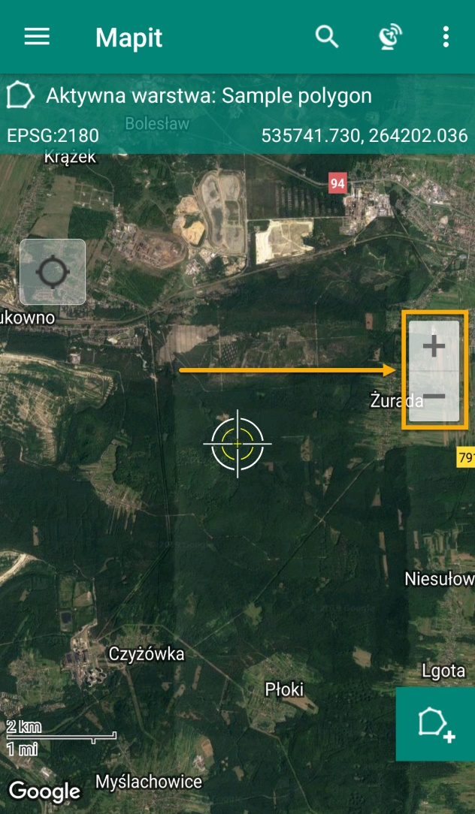

Zoom controls allows users to zoom-in/zoom-out by pressing +/- buttons.

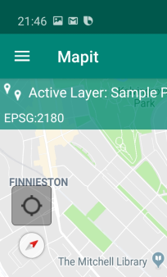  
  
As default the map in Mapit is orientated in North-South direction, some people do prefer however to work with different map orientation. You can enable map rotation in the settings then use standard Google Maps gestures to rotate the map (please touch the map with 2 fingers at the same time then rotate them in needed direction). The map will rotate and below the “Centre on GPS” button small compass will be displayed with the red arrow showing the North. To reset map rotation to N-S please tap the compass icon.

  
  
Enable this option if you would like to keep the map rotating when navigating to feature. This is similar behaviour to e.g. car sat-nav and can be useful in some cases.

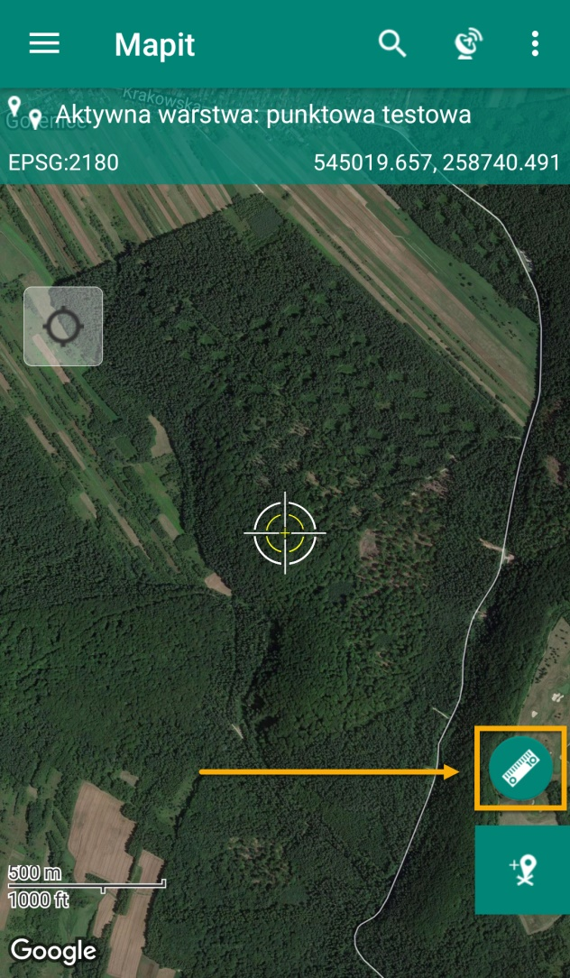

If you do not use measurement tools, to keep the map screen clear you can disable this option to hide the measurement button.

  
  
During measurement operation or standard feature construction during the survey, you can enable the mid-distances labels showing the length for each line or polygon segment.

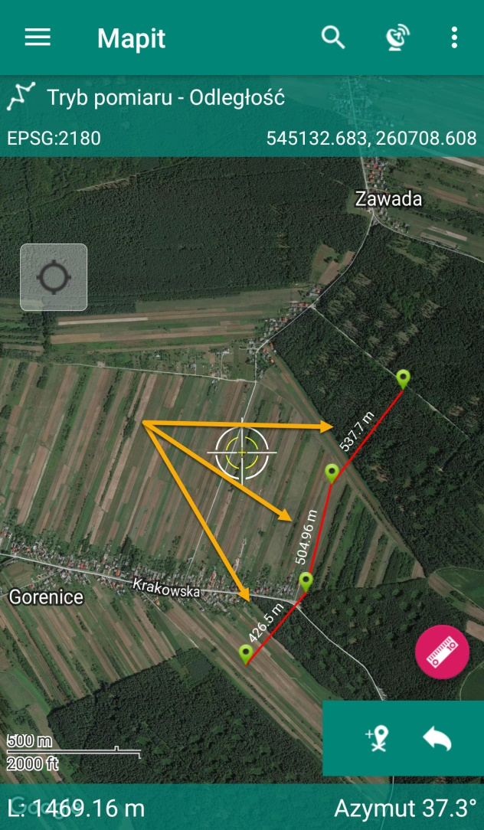



This option will keep the device screen ON – until the app is completely switched off.



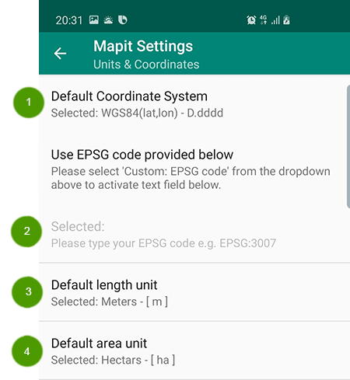



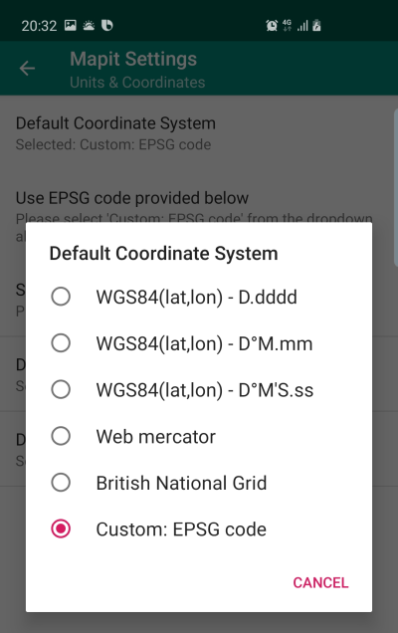There is few WGS84 formats available as well as Web Mercator and British National Grid available on the selection list. If you would like to use your local coordinate system please select the last option on the list and then enter the EPSG numeric code in the next step.



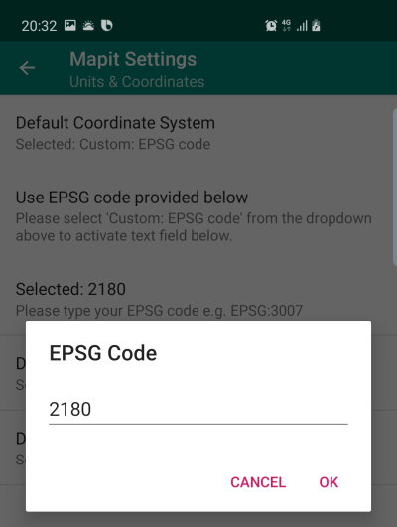Use this setting to provide custom EPSG code. I the code is supported it will be accepted and the coordinates will be converted on the fly using prj4 library.



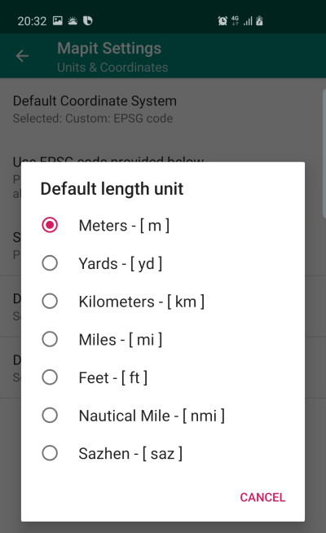



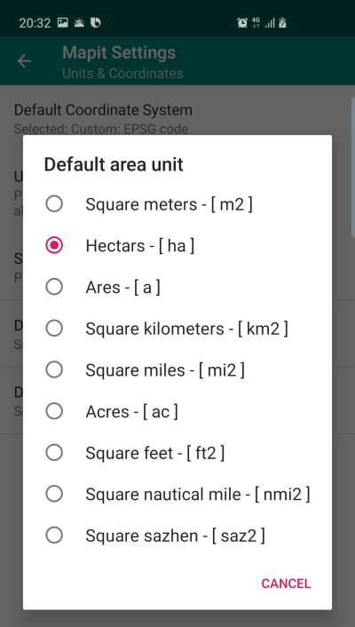



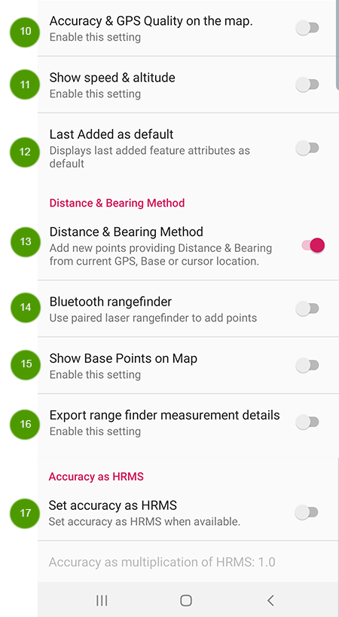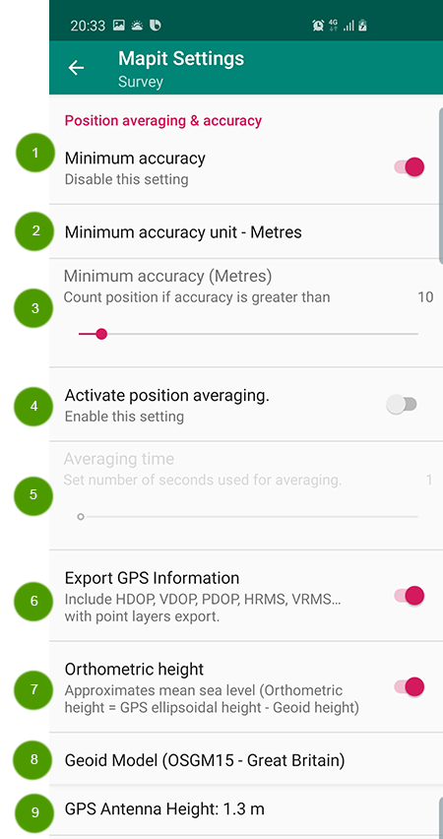



If you would like to register points/vertices only when they meet certain accuracy level, please enable the Minimum Accuracy option and then set the accuracy value in the next step. When the current GPS position does not meet the minimum accuracy settings the point/vertex will not be added and user will get relevant warning on the screen.

  
This option is active only if Minimum accuracy is enabled.

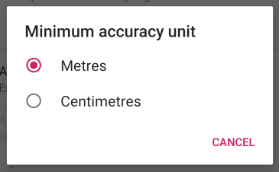

  
Minimum accuracy value set here determine if point feature or vertex will be added to the map.

  
If you would like to record points or vertices by averaging number of positions from certain period of time you can enable this option. Yu can then specify the **number of seconds** – this is the time which will be used to calculate the final position. If you GPS is refreshing the position with 1Hz frequency and if this value is set to 20 – you should be getting the average position calculated from around 20 different measurements.

**NOTE**: If minimum accuracy is set, only positions meeting the accuracy criteria will be taken under consideration by the averaging function.



As mentioned above – please use this option to set the time interval in which the averaging position will be calculated.



Some users need as much as possible information about the survey, including GNSS parameters like DOPs, RMS values, correction station Id etc. You can enable this option to add relevant fields to the export files.

**NOTE**: This option works only for POINT layers.



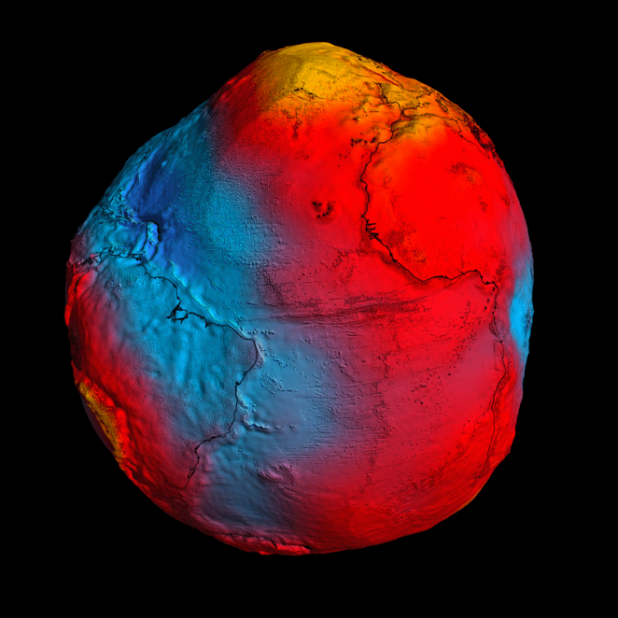Enable this option to allow recording of altitude as orthometric height which approximates so called global mean sea level and represents local vertical datum surface.

The geoid shape passes through the Earth’s crust and is determined from data collected all over the world about the Earth’s gravity field.  The vertical distance between the geoid and the ellipsoid is called the geoid height.  This height can be either negative of positive.  Differences in height between the geoid and ellipsoid (geoid heights) range from roughly -100 to +100 meters.

*The best view yet of Earth’s geoid obtained by GOCE (strongest gravity measurements in yellow, weakest measurements in blue). Credits: ESA/HPF/DLR.*



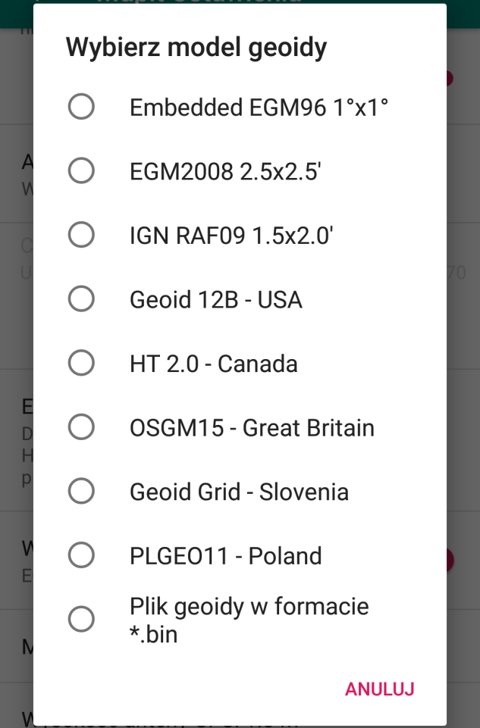Several local geoid grids are available and ready to use in Mapit out of the box including [**GEOID12B**](https://www.ngs.noaa.gov/GEOID/GEOID12B/) (United States), **PLGEO11** (Poland), [**OSGM15**](https://www.osi.ie/wp-content/uploads/2016/08/OSGM15-and-OSTN15-Updated-transformations-for-UK-and-Ireland.pdf) (Great Britain) or **HT 2.0** for Canada.

We have added also support for custom Geoid grids in **\*bin** (US National Geodetic Survey format) – simply convert your local grid to *bin format and rename the file to **LOCAL_GEOID.bin** then place in **Mapit-Spatial→Resources** folder.   
  
When the file is ready enable Orthometric Height and select last option on the list.   
  
Your grid will be used to calculate the orthometric height in Mapit.

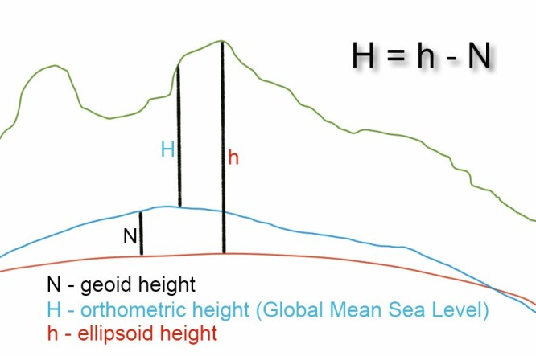



You can set the GPS antenna height here. When this value is >0 the orthometric height is being reduced by the antenna height value, so you will be getting the ground level reading recorded as altitude.

  
Enable this option to get the accuracy & GPS Quality (GPS, DGPS, RTK-Float or RTK-Fix) information displayed below the coordinates on the map.

  
Please enable this option to get speed & altitude displayed on the map below the coordinates.

  
If you are carrying on a survey and you are recording similar attributes for new records you can enable this option to get the “data entry” form automatically populated with the values recorded for the previous feature.

This is particularly useful if there is long list of fields and only one or two values are different.



Project point method for adding points can be used in conjunction with any range finder which measures horizontal distance and true bearing to a target.

**NOTE**: Please check page 66 of this guide for more details.



This option is active when Distance & Bearing Method is enabled. It allows user to automatically input distance and bearing readings from the rangefinder to Mapit.

Please check page 66 for more details.

  
  
When “Base Point” is added during the “Distance & Bearing” survey it can be displayed on the map and the default symbol for it is a red square. Users can enable or disable the base points visibility on the map using this setting.

  
  
If you are using the Project Point Method and the rangefinder as the data input following fields will be added to the exported files when this option is enabled: **baseLat, baseLon, baseElev, tgtHorizontalDistance, tgtBearing, tgtSlopeDistance, tgtVertAngle**.



The HRMS value is available only when NMEA GST message is available.

Typical GTS message looks like:

$GPGST,172814.0,0.006,0.023,0.020,273.6,0.023,0.020,0.031*6A

$σ_{x}$ = LatErr = GST [6]

$σ_{y}$ = LonErr = GST [7]

$σ_{z}$ = AltErr = GST [8]

**VRMS** (2 sigma vertical error) = $2×\sqrt{\frac{1}{1}×{σ_{z}}^{2}}≡{2×σ}_{z}$

**Accuracy** = RMS (1 sigma horizontal error) = $\sqrt{\frac{1}{2}×{{(σ}_{x}}^{2}+{σ_{y}}^{2})}$

**HRMS** = 2 sigma horizontal error = $2×\sqrt{\frac{1}{2}×{{(σ}_{x}}^{2}+{σ_{y}}^{2})}$

If user want to use HRMS (2 sigma error) instead of standard accuracy (1 sigma error) this can be set here.

If there is a need for it or you want to be more confident in terms of accuracy of your measurement you can set whatever multiplier you want for the HRMS value.

Accuracy on GPS Info screen and the recorded value will be also adjusted accordingly to this setting.



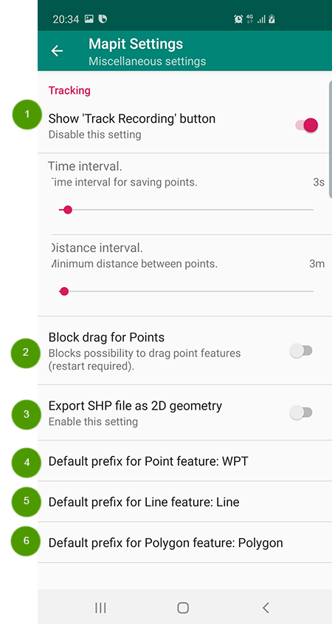



For LINE and POLYGON layers you can use the tracking to construct new features.

It’s very useful tool if you need to gather the data quickly e.g. by driving around the site or recording track from point A to B simply by just walking around.

To use this tool just start any line or polygon feature. The Rec button will show up on the screen. When you press the button a background service will start and new points will be automatically added to your feature as you move forward.

The track recording process is running in the background so you can do other things on your device and the points will be registered anyway even the app is not visible on the screen. To save battery you may switch the screen off as well. When the ‘Track recording’ process is active.

You can also specify additional parameters for the tracking here.

**Time interval** – new points will be recorded only if the time interval between last recorded position and NOW is greater than specified here in seconds.

**Distance interval** – new points will be registered only if the distance between the last recorded point and current location is greater than the value specified here in meters.

There are also some known issues connected to tracking and polygon features caused by current SDK limitations:

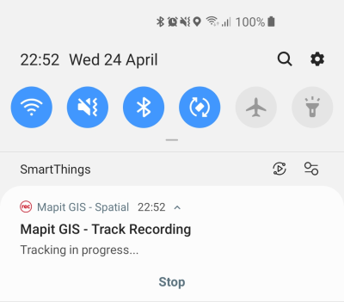When number of points in single polygon exceed 2000 the polygon fill will may not be visible.

When polygon does contain self- intersections the polygon fill will may not be visible as well.

To stop tracking process please press stop button on the notification, press the ‘Rec’ button on the map or ‘END’ feature button on the map toolbar.



As default you can **drag** the point feature to new location by simply **long press** and **drag**. When this setting is enabled this functionality can be blocked. Sometimes it can be important that this functionality is blocked so you can avoid accidental dragging of the point to new location.

  
  
As default the export to shapefile does include the Z dimension. Some systems do require 2D geometry. If this is a case you can enable this option to force 2D geometry for shapefiles.

  
If the active layer contains the field called **name**, when you create new point the prefix specified here will be added to the default name. As default **WPT** value is set for point layers and following names will be created for new features: **WPT 1, WPT 2** etc.

You can specify your own value here or remove it if necessary.

  
This setting is working the same way as described above for points.

  
This setting is working the same way as described above for points.



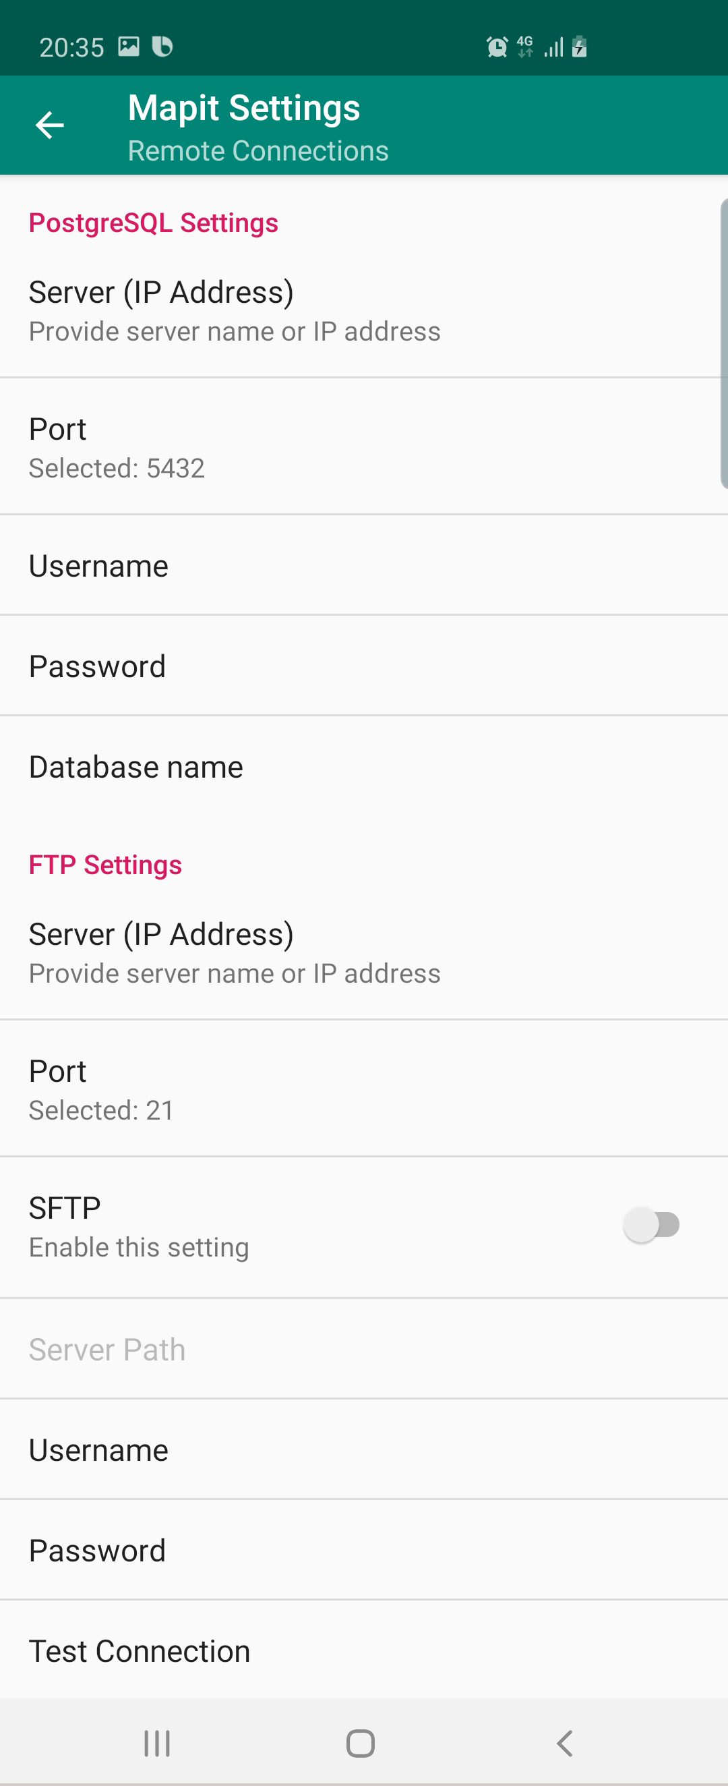Alternatively, to accessing the data directly from geopackage file there is an option to export the collected data to files.

Files can also be exported to FTP/SFTP – please set the connection details for your FTP or SFTP server to be able to use this option for import and export of the data.

Direct export of the collected data to PostgreSQL database is also available.

Make sure your database is having the PostGIS extension installed and can be accessed from Internet.

Please check page 47 for more details.



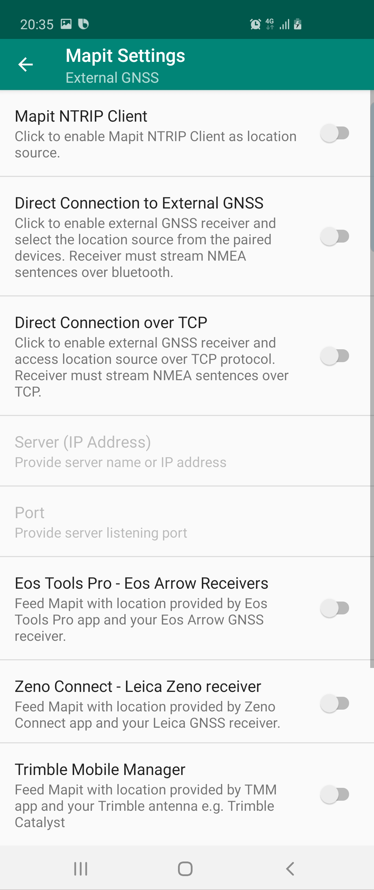External GNSS connections allows to utilise accurate location provided by high-quality GNSS receivers. In theory **Mapit Spatial** can be connected to any Bluetooth or TCP enabled device streaming the data using [NMEA](http://www.nmea.org/) standard. If the device is capable of streaming RTK corrected coordinates you get centimetre accuracy.

GNSS metadata statistics are visible in GPS Info screen and recorded by **Mapit Spatial** for Point features. They can be added to the exported files as separate fields when exporting to geojson or shapefile. This option must be enabled in “Survey Settings”.

On top of the standard (direct) connections via Bluetooth or TCP some GNSS receivers offer dedicated connections via apps like [**Trimble Mobile Manager**](https://play.google.com/store/apps/details?id=com.trimble.trimblemobilemanager)**,**[**EOS Tools Pro**](https://play.google.com/store/apps/details?id=com.eos_gnss.eostoolspro)**or**[**Leica Zeno Connect**](https://play.google.com/store/apps/details?id=com.leica.zenoconnect). These can be the source of the GNSS location for your Android device and feed the location manager via a so called “Mock location”.

Mapit Spatial can also utilise Mock locations provided by any other apps like “Bluetooth GPS”, however some GNSS metadata may not always be available in that mode.

**NOTE:** If you would like to get **mean sea level height** in Mapit Spatial – please enable Geoid Height (Survey Settings) and select the relevant Geoid Grid from the list.

To connect external GNSS device to Mapit Spatial – please go to **Settings → External GNSS** and switch on relevant option:

**I. Direct External GNSS Connection via Bluetooth or TCP socket** – this method of connection should be used if you want to connect Mapitdirectly to the source streaming NMEA sentences via the Bluetooth or TCP interface. If you want to get RTK corrected location via this method of connection you have to have a device which is able to stream NMEA with the solution applied.

The app was tested with number of receivers like Garmin GLO or professional [marXact UNI-GR1](https://www.marxact.com/mapit-gis-marxact).

**To connect external GNSS device to Mapit Spatial please follow the following steps:**

1. Make sure the device is paired in Bluetooth settings.
2. In Mapit Settings go to External GPS and switch ON Direct Connection to External GNSS or Direct Connection over TCP switch.
3. When getting back to map the location source will be automatically switched to External GNSS (users may need to restart application on some devices).

**II.**[**Eos Tools Pro Connection**](https://play.google.com/store/apps/details?id=com.eos_gnss.eostoolspro) – Enable this function if you would like to make Mapit compatible with [Eos Arrow receivers](https://eos-gnss.com/about-positioning-systems/). Eos Tools Pro must be installed and configured on your device before using Mapit GIS. These Tools feature an NTRIP client to receive corrections from an RTK network/Internet base station and feed these corrections to your Arrow receiver via Bluetooth. They will also take care of populating the Android Location Service with the Arrow’s more accurate position (replacing the device’s internal position with the Arrow’s position) – this position is then used by the **Mapit** app.

1. Make sure the EOS Tools is selected as Mock Location app in the Android developer settings.
2. Connect your GNSS receiver via EOS Tools and enable Mock Location inside the EOS Tools Pro – make sure you are getting the RTK corrections correctly.
3. When you get accurate location in EOS Tools Pro – switch to Mapit and in the External GNSS Settings → EOS Connect on.
4. You can enable GNSS metadata for export in Survey settings as well if you need.
5. In this mode you will not get the satellite’s signal and satellite’s position views – as they are not available via mock location.

**III.** [**Leica Zeno Connect**](https://play.google.com/store/apps/details?id=com.leica.zenoconnect)– please use this method for the connection with Leica smart antennas.  The Zeno Connect app must be installed and configured on your device before using Mapit GIS. MapIt has been tested using Leica Smart Antenna GG03/04.  Please follow the steps below to get the accurate location inside **Mapit**:

1. Make sure the Zeno Connect is selected as Mock Location app in the Android developer settings.
2. Connect your Leica Smart Antenna via Zeno Connect and enable Mock Location inside the app – make sure you are getting the RTK corrections correctly.
3. When you get accurate location in Zeno Connect – switch on Mapit and go to External GNSS Settings → Switch on Leica Zeno Connect switch.
4. You can enable GNSS metadata for export in Survey settings as well if you need.
5. In this mode you will not get the satellite’s signal and satellite’s position views – as they are not available via mock location.

**IV.** [**Trimble Mobile Manager**](https://play.google.com/store/apps/details?id=com.trimble.trimblemobilemanager) – please use this method for the connection with Trimble antennas like the [Trimble Catalyst](https://catalyst.trimble.com/).  The Trimble Mobile Manager app must be installed and configured on your device before using Mapit GIS.  Please follow the steps below to get the accurate location inside Mapit:

1. Make sure the Trimble Mobile Manager is selected as Mock Location app in the Android developer settings.
2. Connect your Trimble Catalyst Antenna via Trimble Mobile Manager app and enable Mock Location inside the app – make sure you are getting the RTK corrections correctly.
3. When you get accurate location in TMM – switch on Mapit and go to External GNSS Settings → Switch ON Trimble TMM switch.
4. You can enable GNSS metadata for export in Survey settings as well if you need.

**V.**You can also use any other app providing Mock Locations like “Bluetooth GPS” to get the location inside Mapit leave External GNSS settings switched off in that case. GNSS metadata statistics like DOPs values, RMS values etc. may however will not be available in that mode.



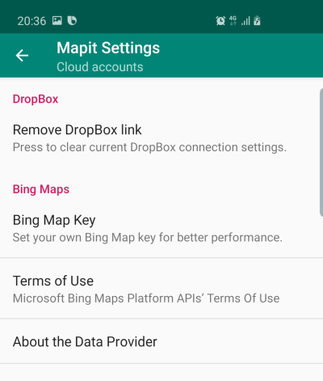

In this section you can authorize dropbox or remove dropbox link, provide your own Bing Map key if required and get information about Bing Maps Terms of Use.



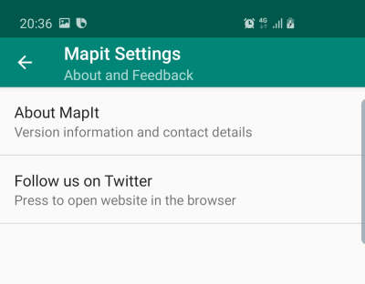 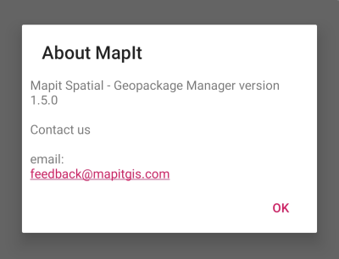

If you need to check the current Mapit version or contact us, please use this option.

**APPENDIX 1 – Mapit Spatial folder’s structure**

During the installation there is a folder structure created on the **DEVICE MEMORY -> Mapit-Spatial**where all application content is stored.

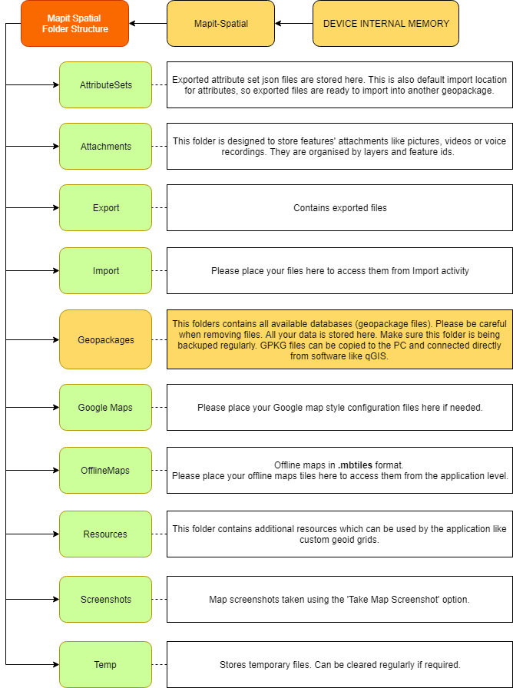

**APPENDIX 2 – Mapit Spatial vs. Mapit Pro**

